WP3 - Design of joint micro credential course

D3.4 Teaching and training materials

Making simple products with 3D printing
A training program that leads to micro credentials

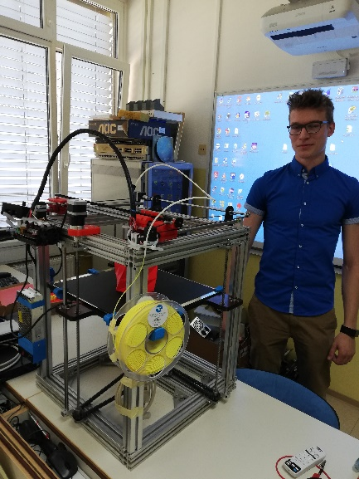
Picture 1: 3D printer at school (by Tomaž Pintarič)

Prepared by:

Ivan Slinkar, dipl.ing, Šolski center Novo mesto
Boštjan Škrabec, dipl.ing, Šolski center Novo mesto
Tomaž Pintarič, univ.dipl.ing, Šolski center Novo mesto

TABLE OF CONTENTS

1 THE HISTORY OF 3D PRINTING 6
1.1 The beginnings of 3D printing (1980–1990) 6
1.2 Development and diffusion of technologies (1990–2010) 8
2 DIFFERENCES BETWEEN TRADITIONAL AND ADDITIVE MANUFACTURING 12
2.1 Basic principle of production 12
2.2 Material consumption efficiency 13
2.3 Industrial use 13
3 3D PRINTING MATERIALS IN FDM TECHNOLOGY 14
3.1 PLA (Polylactic Acid) 14
3.2 ABS (Acrylonitrile Butadiene Styrene) 14
3.3 PETG (Polyethylene Terephthalate Glycol-modified) 15
3.4 TPU (Thermoplastic Polyurethane) 15
3.5 Nylon (Polyamide) 15
3.6 PC (Polycarbonate) 16
3.7 Special filaments for 3D printing in FDM technology 16
3.7.1 Wood filaments 17
3.7.2 Carbon Fiber Filaments 17
3.7.3 Silk filaments 18
3.7.4 Multicolour filaments 18
3.7.5 Gradient (Colour-Changing) filaments 19
4 BASIC PARTS AND PRINCIPLE OF OPERATION OF A 3D PRINTER 21
4.1 3D printer frame 21
4.2 Extruder and nozzle 21
4.3 Print Surface (Work Plate) 22
4.4 Panning mechanism (X, Y, Z axis) 22
4.5 Power supply and control electronics 22
5 PREPARATION OF THE 3D PRINTER AND MATERIALS FOR PRINTING 24
5.1 Preparing the 3D printer 24
5.1.1 Selecting and Setting Up a Printer 24
5.1.2 Calibrating the Print Surface 24
5.1.3 Adjusting the temperature of the nozzle and heating plate 25
5.1.4 Extruder calibration 25
5.2 Preparation of materials for printing 26
5.2.1 Filament selection 26
5.2.2 Proper storage of filaments 26
5.2.3 Preparing the filament for printing 26
6 SAFETY PROCEDURES WHEN WORKING WITH A 3D PRINTER 27
6.1 Preparing the workspace 27
6.2 Personal protective equipment 27
6.3 Proper handling of filament and materials 27
6.4 Prevention of mechanical damage 27
6.5 Electrical safety 28
6.6 Fire safety 28
6.7 Proper Printer Maintenance 29
6.8 Security when removing printed objects 29
6.9 Responsible waste management 29
6.10 Handling Hazardous Substances When Cleaning the Printer 29
6.11 Teaching and raising awareness of users 30
7 PARAMETER SETTING AND PRINT MONITORING 31
7.1 Setting Print Parameters 31
7.1.1 Basic Printing Parameters 31
7.2 Print monitoring and problem detection 35
7.2.1 Possible problems during printing 35
7.2.2 Adjust settings during printing 38
8 3D PRINTING AND FINISHING OF PRINTED MATERIALS 39
8.1 Implementation of 3D printing 39
8.1.1 Product printing 39
8.1.2 Monitoring the printing process and detecting errors 39
8.2 Removing the Product from the Printer 40
8.2.1 Use the Product Removal Tool 40
8.2.2 Printer Cleaning Procedures After Printing 41
8.3 Completing the model 42
8.3.1 Mechanical and chemical finishing techniques 42
9 CALCULATION OF THE COST OF 3D PRINTING 44
9.1 Material cost 44
9.2 Energy costs 44
9.3 Printer wear costs 45
9.4 Post-processing costs 45
9.5 Calculation example 45
10 MODELING SIMPLE 3D MODELS WITH ONSHAPE 46
10.1 Selecting a web browser and opening a user profile 47
10.2 User Interface Settings 48
10.3 Creating a new document 50
10.4 Onshape document 51
10.5 Sketch 53
10.6 PRACTICAL MODELING TASKS WITH ONSHAPE 56
10.7 Task 1 56
10.8 Task 2 60
10.9 3D Model Building Blocks 64
10.10 Task 3 70
10.11 Task 4 72
10.12 Task 5 76
10.13 Task 6 77
11 Exporting 3D models 84
12 Conclusion 85
13 Bibliography 86

PICTURE INDEX

Picture 1: 3D printer at school (by Tomaž Pintarič) 1
Picture 2: Hideo Kodama (The 3D Printing Journal) 6
Picture 3: Chuck Hull, American engineer, who invented and patented stereolithography (SLA) (3D Printing Industry) 7
Picture 4: Stereolithography scheme (3D Printing Industry) 7
Picture 5: Fused Deposition Modeling (FDM) (Introduction to Fused Deposition Modeling (FDM) 8
Picture 6: Printing using FDM technology (Introduction to Fused Deposition Modeling (FDM) 8
Picture 7: Selective Laser Sintering (SLS) (3D Printing: The Next Industrial Revolution) 9
Picture 8: RepRap Printer (3D Printing: The Next Industrial Revolution) 9
Picture 9: Commercialization and popularization (2010–present) (Wikipedia 1) 10
Picture 10: 3D printing of human organs (Računalniške novice) 11
Picture 11: 3D printing of concrete structures (3Dnatives Europe) 11
Picture 12: Multi-coloured silk filaments (Amazon) 19
Picture 13: Gradient (Colour-Changing) filaments (Amazon) 20
Picture 14: Extruder construction (The University of Texas at Arlington) 21
Picture 15: Scrolling mechanism (The University of Texas at Arlington) 22
Picture 16: Power supply and control electronics (by Ivan Slinkar) 23
Picture 17: Calibration (calibration) of the printing surface (by Ivan Slinkar) 24
Picture 18: Manual calibration of the print surface (by Ivan Slinkar) 25
Picture 19: Under- or over-extrusion (Prusa Research) 25
Picture 20: Proper storage of filaments (by Ivan Slinkar) 26
Picture 21: Symbol – Do not reach into the danger zone (by Ivan Slinkar) 28
Picture 22: Symbol - Risk of electric shock (by Ivan Slinkar) 28
Picture 23: Symbol – Caution hot surface (by Ivan Slinkar) 28
Picture 24: Hazard symbol – Follow the instructions (by Ivan Slinkar) 29
Picture 25: Symbol – Caution Hazardous Substance (by Ivan Slinkar) 30
Picture 26: Print quality at different print speeds (Innovative Drive Systems) 32
Picture 27: Different layer thicknesses (Innovative Drive Systems) 33
Picture 28: Different filler density (Innovative Drive Systems) 33
Picture 29: Different types of fillers (Innovative Drive Systems) 34
Picture 30: "Support" (Innovative Drive Systems) 34
Picture 31: ABS cracking due to excessive cooling during printing (Innovative Drive Systems) 34
Picture 32: Poor adhesion of the first layer (by Ivan Slinkar) 35
Picture 33: The distance of the table from the nozzle (Prusa Research) 36
Picture 34: Wrapping (Prusa Research) 36
Picture 35: Threading "stringing" (Prusa Research) 37
Picture 36: Cleaning the nozzle with a needle (by Ivan Slikar) 37
Picture 37: Printing error detection (by Ivan Slinkar) 40
Picture 38: Removing the product with a scraper (by Ivan Slinkar) 41
Picture 39: Nozzle needs cleaning (by ivan Slinkar) 41
Picture 40: Product Cleaning Tools (by Ivan Slinkar) 42
Picture 41: Removing Support (by Ivan Slinkar) 43
Picture 42: 3D CAD Model (by Boštjan Škrabec) 46
Picture 43: Sketch (by Boštjan Škrabec) 53

THE HISTORY OF 3D PRINTING
3D printing, also known as additive manufacturing, is one of the most innovative technologies today that is changing many industries. Its history dates back to the 80s of the last century, when pioneers developed the first methods for the manufacture of three-dimensional objects with the gradual loading of materials. From the first patents to widespread commercialization, 3D printing has come a long way, which we will explore below.

The beginnings of 3D printing (1980–1990)
The concept of 3D printing first emerged in the early '80s, when researchers and engineers were looking for ways to prototype products faster. The first documented attempt at three-dimensional printing was in 1981, when Japanese engineer Hideo Kodama developed a system for creating three-dimensional objects using UV light to solidify layers of liquid polymer. Despite the innovation of his approach, however, he was unable to obtain a patent.

Picture 2: Hideo Kodama (The 3D Printing Journal)
In 1984, French engineers Alain Le Méhauté and Jean-Claude André also developed a similar concept, but failed to secure funding for further development of the technology. Nevertheless, a key breakthrough occurred in the same year when Chuck Hull, an American engineer, invented and patented stereolithography (SLA), one of the first methods of 3D printing. Hull founded 3D Systems in 1986, which began developing the first commercial 3D printers (The 3D Printing Journal).
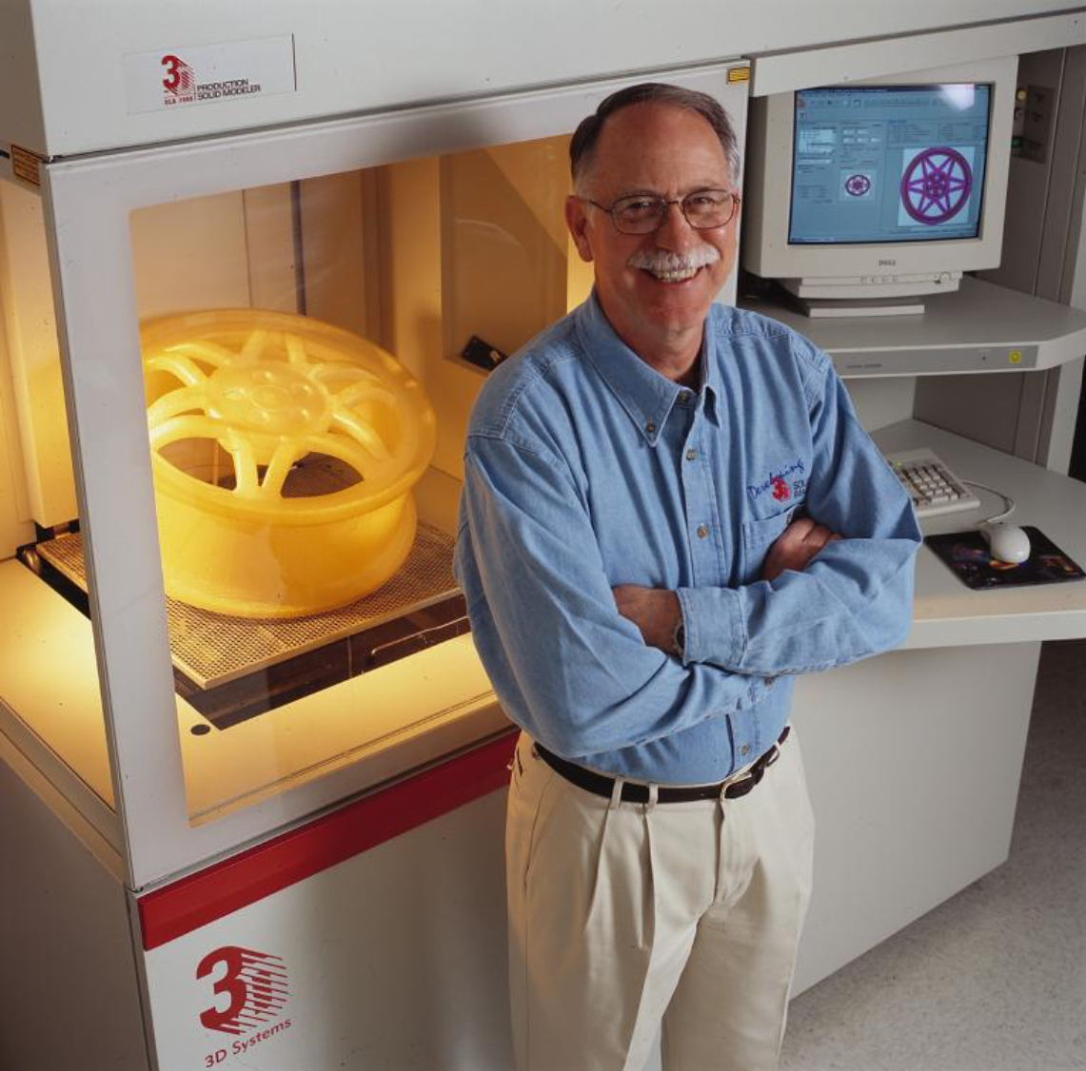
Picture 3: Chuck Hull, American engineer, who invented and patented stereolithography (SLA) (3D Printing Industry)
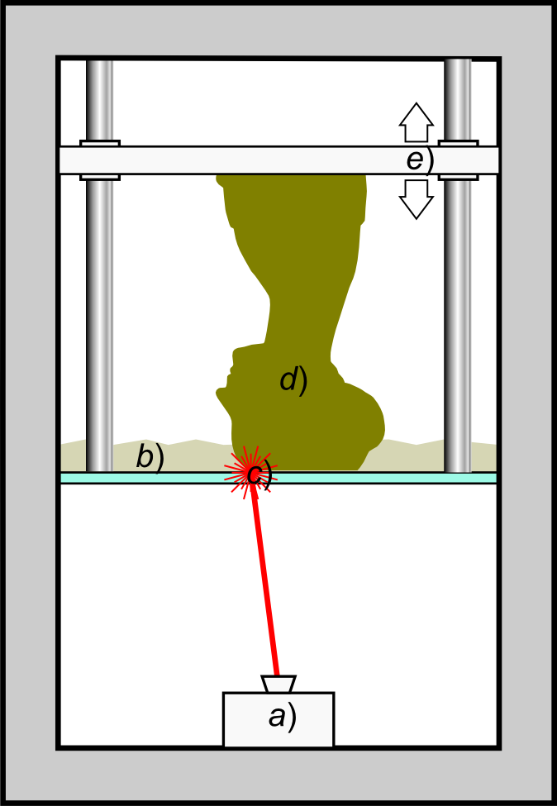
Picture 4: Stereolithography scheme (3D Printing Industry)
Stereolithography scheme: light emitter a) Laser or DLP selectively illuminates the transparent bottom of c) tank b) filled with liquid photopolymerizing resin. The solidified resin d) is gradually raised by means of a lifting platform e).

Development and diffusion of technologies (1990–2010)
In the 90s, new technologies emerged that further expanded the possibilities of 3D printing. In 1988, Scott Crump developed the Fused Deposition Modeling (FDM) method, in which molten thermoplastic material is applied layer by layer until the final product is formed. Crump founded Stratasys, which has become one of the leading companies in the field of 3D printing.
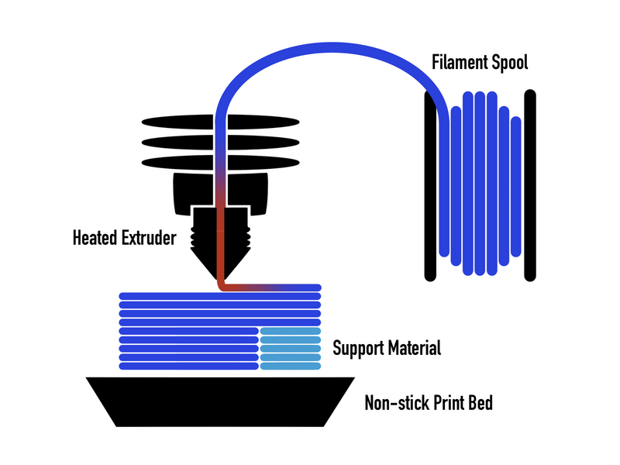
Picture 5: Fused Deposition Modeling (FDM) (Introduction to Fused Deposition Modeling (FDM)
Fused Deposition Modeling (FDM) is an additive manufacturing process in which an object is formed by extruding molten material along a predetermined path layer by layer.
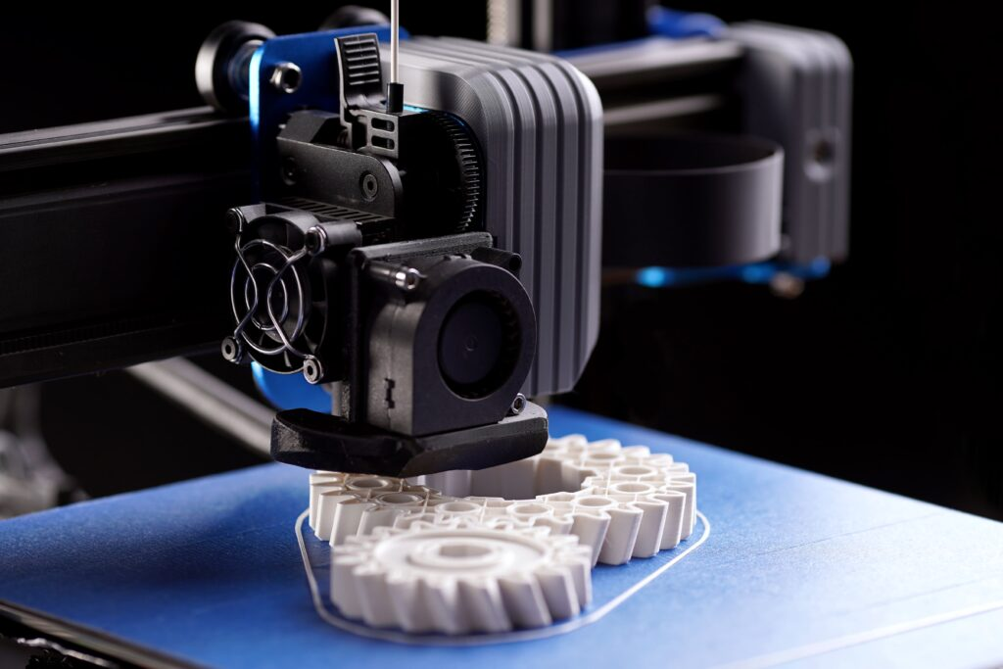
Picture 6: Printing using FDM technology (Introduction to Fused Deposition Modeling (FDM)
Another important development during this period was the Selective Laser Sintering (SLS) technology developed by Carl Deckard at the University of Texas. This method uses lasers to selectively fuse powdered materials into three-dimensional objects, which makes it possible to produce complex geometries and strong structures.
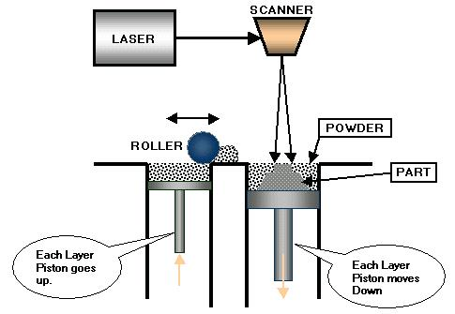
Picture 7: Selective Laser Sintering (SLS) (3D Printing: The Next Industrial Revolution)
While 3D printing was initially limited to industrial use, the first research projects for more affordable printers also began to emerge during this period. In 2005, RepRap (Replicating Rapid Prototyper) was introduced, an open-source project that allowed the production of low-cost 3D printers capable of self-replication. This project has greatly contributed to the popularization of 3D printing among the general public.
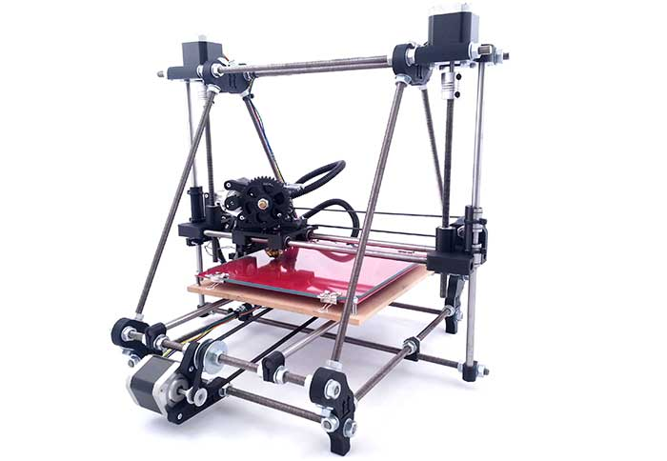
Picture 8: RepRap Printer (3D Printing: The Next Industrial Revolution)
Many versions of the RepRap printer have been created, based on open-source models and software with a free license.
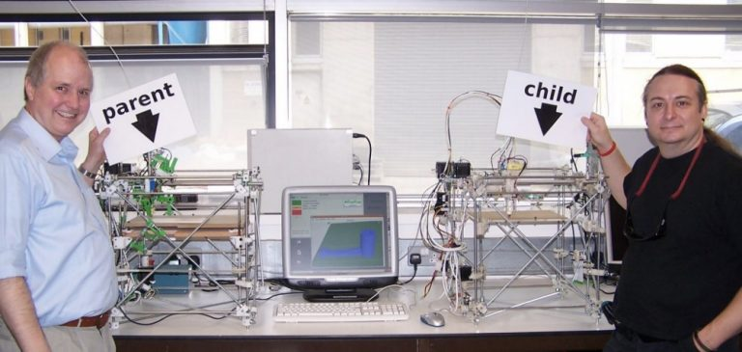
Picture 9: Commercialization and popularization (2010–present) (Wikipedia 1)
After 2010, 3D printing experienced a major breakthrough. Due to the expiration of patents for FDM technology, many companies, such as MakerBot and Ultimaker, have begun producing affordable 3D printers for home and professional use. This has enabled the wider use of 3D printing in fields such as design, medicine, education, and even in the art field (Wikipedia).
3D printing has become especially important in medicine, where it is used to make customized prostheses, implants, and even bioprinting organs. In the automotive and aerospace industries, companies such as Boeing and Tesla are using 3D printing to make complex components that reduce weight and production costs.
In recent years, even more innovative applications of 3D printing have emerged, including food printing, building houses, and making personalized products. The technology is developing at an incredible speed, and experts predict that in the future it will play a key role in manufacturing, medicine and even space research.
In a few decades, 3D printing has gone from an experimental technology to an indispensable tool for industry and home users. From Chuck Hull's first SLA printers to today's advanced methods of printing organs and entire buildings, the evolution of 3D printing is incredible. With further technological advances, this innovation will continue to change the way we design and manufacture products in the 21st century.

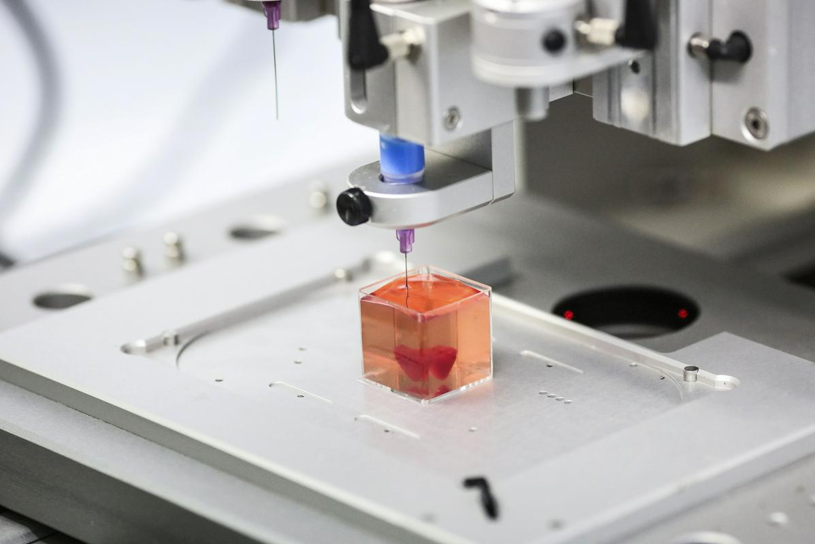
Picture 10: 3D printing of human organs (Računalniške novice)
American scientists have managed to make a big breakthrough. With a 3D printer, functional parts of the human heart, including heart valves, were printed from collagen using a special technology.

Picture 11: 3D printing of concrete structures (3Dnatives Europe)
The printed house is located in Westerlo, in northern Belgium. The project was supported by the European Regional Development Fund (ERDF). The project aims to encourage the construction industry to use 3D printing of concrete structures.

DIFFERENCES BETWEEN TRADITIONAL AND ADDITIVE MANUFACTURING

Industrial manufacturing has been evolving for centuries, with two main approaches predominating: traditional manufacturing, which involves removing or transforming the material, and additive manufacturing, which builds the product layer by layer. Each method has its own advantages and disadvantages, depending on the requirements of the final product, cost-effectiveness and design flexibility.

Basic principle of production

Traditional production:

- Traditional production methods include removal, transformation and aggregation processes:
- Removal processes (CNC milling, turning) shape the product by removing material from a larger piece of raw material.
- Transforming processes (casting, forging, plastic injection moulding) use moulds or dies to form products from liquid or semi-solid materials.
- Joining processes (welding, gluing) make several parts into a whole.
This method of production is very effective in mass production, as it allows for precision and repeatability of products.

Additive manufacturing (3D printing):

- Additive manufacturing, also known as 3D printing, is based on the gradual addition of material. Computer-controlled printers apply material layer by layer to form the final product.

The main methods of additive manufacturing include:
- FDM (Fused Deposition Modelling) – melting and application of plastic filaments.
- SLA (Stereolithography) and DLP (Digital Light Processing) – curing of liquid resin with light.
- SLS (Selective Laser Sintering) – joining dusty materials with a laser.

The main advantage of additive manufacturing is the ability to produce complex shapes without the need for additional tools such as moulds.

Material consumption efficiency
Traditional production often generates a lot of material waste, as CNC machining removes parts of the raw material. Plastic casting and injection moulding are more efficient, but require mould making, which can be expensive.
Additive manufacturing uses only as much material as is needed for the final product, which reduces waste. Some processes (such as SLS) even allow the recycling of unused dust.
The result: 3D printing is more sustainable, as it uses fewer raw materials and reduces waste. It is a better choice for products with complex shapes and individualized components.
Additive manufacturing allows for a high degree of design flexibility – it is not limited by machine tools or moulds, which allows the production of complex structures (e.g. hollow or organic forms) that would be very difficult or even impossible in traditional production. Traditional production is limited to complex geometries, as it requires the assembly of several parts or the use of special tools. Any design change can increase costs due to the need for new molds or customization of CNC programming.

Industrial use
Traditional manufacturing is widely used in automotive, aerospace, construction, and mass production of electronic components. It enables the production of robust, durable and extremely precise parts.
Additive manufacturing is used in rapid prototyping, medicine (implants, dentures), aerospace (light but strong parts) and in the production of personalized products.
Traditional production is cheaper in mass production, since the one-time cost for tools and moulds is distributed over a large volume of products. Additive manufacturing is cheaper for smaller batches or unique products because it doesn't require expensive tools. It also allows for rapid prototyping.
3D printing is slower in mass production, as each product is created layer by layer. In contrast, plastic injection moulding is extremely fast in large quantities. Additive manufacturing allows for greater flexibility, less waste and rapid prototyping, but it is slower and less suitable for mass production. A combination of both methods is often the best solution – traditional production for batch products, and 3D printing for innovation and personalized parts.

3D PRINTING MATERIALS IN FDM TECHNOLOGY
FDM (Fused Deposition Modeling) is one of the most commonly used 3D printing technologies, in which a plastic fiber (filament) is melted and applied layer by layer until the final product is created. The success of printing and the properties of the final model strongly depend on the choice of material. The most common materials used in FDM printing are described below, along with their features, advantages and disadvantages.

PLA (Polylactic Acid)
PLA is one of the most popular materials for 3D printing because it is easy to use and environmentally friendly. It is made from renewable resources such as corn starch and is biodegradable.
Advantages:
- Easy to print (does not require a heated table).
- Low printing temperature (180-220 °C).
- Biodegradable and environmentally friendly.
- Available in many colours and translucent versions.
Disadvantages:
- Low heat resistance (softens at temperatures above 60 °C).
- More fragile than other materials.
- It is not resistant to UV light and moisture.

ABS (Acrylonitrile Butadiene Styrene)
ABS is a strong and durable material that is widely used in industrial applications. It is more resistant to shock and heat than PLA, but it is also more difficult to print.
Advantages:
- High mechanical strength and impact resistance.
- Good heat resistance (softening at approx. 105 °C).
- The possibility of post-processing (grinding, gluing, chemical smoothing with acetone vapours).
Disadvantages:
- It needs a heated table (recommended temperature 90-110 °C).
- Greater chance of warping.
- During printing, it emits unpleasant fumes, so it is recommended to print in a well-ventilated area.

PETG (Polyethylene Terephthalate Glycol-modified)
PETG combines the advantages of PLA and ABS and offers good mechanical strength and easy printing. It is resistant to water and chemicals, which makes it ideal for functional parts.
Advantages:
- Resistant to moisture, chemicals and shocks.
- Less possibility of twisting than with ABS.
- Good flexibility and strength.
- Suitable for use in contact with food (if properly certified).
Disadvantages:
- Prone to stringing.
- A little more experimentation with the printing temperature is required (220-250°C recommended).

TPU (Thermoplastic Polyurethane)
TPU is a flexible material that allows you to print flexible designs such as seals, protective liners and footwear.
Advantages:
- High flexibility and wear resistance.
- Resistant to oils, chemicals and wear.
- It can be used for printing moving parts.
Disadvantages:
- Heavier to print (requires slower print speeds).
- Not suitable for all types of extruders (works better with direct filament drive).

Nylon (Polyamide)
Nylon is extremely strong, durable and wear-resistant, which is why it is popular for functional and mechanically stressed parts.
Advantages:
- High strength and wear resistance.
- Good flexibility and shock resistance.
- It holds the thread perfectly and sticks well between the layers.

Disadvantages:
- It strongly absorbs moisture from the air, which can cause problems with printing.
- Requires a higher printing temperature (240-270 °C).
- The possibility of twisting when printing.

PC (Polycarbonate)
Polycarbonate is one of the strongest and most heat-resistant materials for FDM printing. It is often used for industrial applications and high-performance parts.
Advantages:
- Extremely strong and durable material.
- High heat resistance (up to 150 °C).
- Resistant to shocks and deformation.
Disadvantages:
- It requires very high printing temperatures (260-310 °C).
- It strongly absorbs moisture, which can affect the quality of the print.
- It requires a closed chamber for better results.

Choosing the right material for 3D printing is crucial to the success of the project. If we need easy and fast printing, PLA is the best choice. For mechanically durable parts, ABS or PETG is a better option. For flexible models, TPU is ideal, while Nylon and PC are used for industrial applications where high strength and heat resistance are required.
Each material has its own advantages and disadvantages, so it is important to take into account the requirements of the final product and the characteristics of the printer when choosing.

Special filaments for 3D printing in FDM technology
In addition to standard materials such as PLA, ABS, PETG, TPU, and Nylon, there are also special filaments that have unique properties and visual effects. These filaments are often a mixture of base material and additives such as wood particles, carbon fibre, or metal powder. In addition, there are also aesthetically interesting materials such as silk, multicolour and colour-changing.

Wood filaments
Wood filaments are a mixture of PLA and fine wood particles (about 30%). This gives the printed models the look and feel of real wood.
Advantages:
- Authentic wood texture and natural look.
- Possibility of sanding, varnishing and painting.
- Less tendency to twist than ABS.
Disadvantages:
- Faster wear of the nozzle (hardened steel nozzle is recommended).
- The material can be fragile and therefore requires a slower print speed.
- Wood particles can clog the extruder if the filament is not of good quality.

💡 Tip: Print at 190-220°C and use a larger nozzle (at least 0.5mm) to prevent clogging.

Carbon Fiber Filaments
Carbon filaments are basic materials (usually PLA, PETG or Nylon) with the addition of tiny carbon fibers. This increases the strength and rigidity of the models, while reducing their weight.
Advantages:
- High strength and rigidity.
- Less chance of deformation when printing.
- Lighter models compared to conventional plastomeres.

Disadvantages:
- Very abrasive – strongly wears standard nozzles (hardened steel nozzle is required).
- Higher price compared to standard filaments.
- It is not as flexible as the base material.
💡 Tip: Recommended printing temperature 220-260 °C, using a hardened steel nozzle (at least 0.6 mm) to extend the life of the printer.

Silk filaments
Silk filaments are usually PLA with special additives that give the printed objects a high gloss and a smooth surface.
Advantages:
- Extremely shiny and smooth look.
- No need for post-treatment to achieve shine.
- Easy to print, similar to PLA.
Disadvantages:
- Lower mechanical strength than standard PLA.
- Inferior layer adhesion, so it is not ideal for functional parts.
💡 Tip: Print at 200-220°C, at a slightly lower speed for better layer adhesion.

Multicolour filaments
Multi-coloured filaments contain several different colours in one tube, which makes it possible to print objects with multiple shades without the need to change the filament.

Types of multi-coloured filaments:
- Duo/Tri-Colour: They have two or three colours in one filament that alternate.
- Rainbow: The colours gradually change along the entire filament.
Advantages:
- An easy way to achieve multi-coloured designs.
- There is no need for a double extruder or manual filament change.
Disadvantages:
- It is not possible to control the exact transition of colours.
- Larger models are more suitable, as colour transitions require more filament.
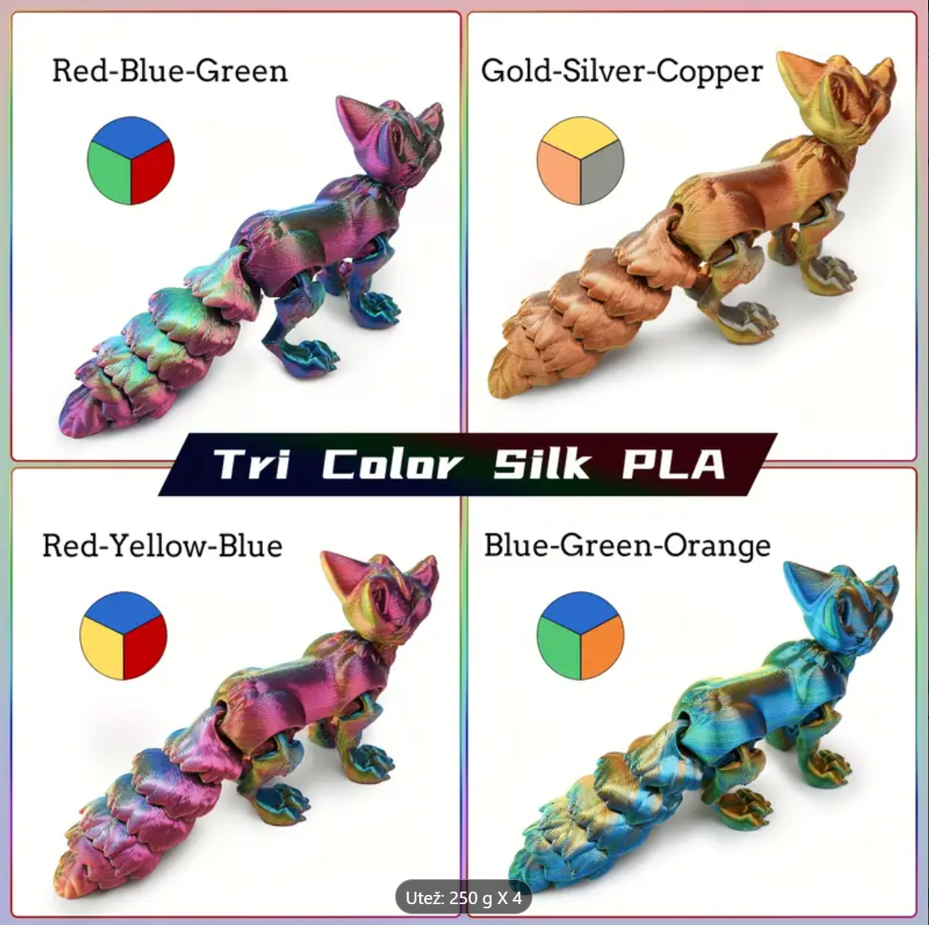
Picture 12: Multi-coloured silk filaments (Amazon)
💡 Tip: Adjust the orientation of the model so that the color gradient is most visible on the parts you want.

Gradient (Colour-Changing) filaments
These filaments change colour depending on temperature or light. There are two main types:
- Thermochromatic: They change colour at different temperatures.
- Photochromatic: They change colour under UV light.
Advantages:
- Fun and visually appealing effect.
- Useful for interactive models (e.g. cups that change colour with the temperature of the liquid).
Disadvantages:
- Colour change can weaken the material.
- Limited choice of colours and shades.
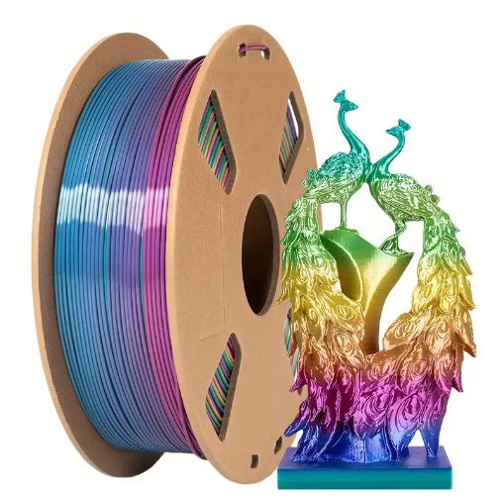
Picture 13: Gradient (Colour-Changing) filaments (Amazon)
💡 Tip: Print at 190-220°C and experiment with warm/cool temperatures to test the colour change.

Special filaments open up new possibilities in 3D printing, as they offer unique visual and mechanical properties. Among the most popular are:
- Wooden filaments for a natural look.
- Carbon filaments for increased strength and rigidity.
- Silk filaments for glossy and smooth surfaces.
- Multi-coloured and gradient filaments for aesthetically appealing designs.

When choosing these filaments, it is important to consider the properties of the material and adjust the print settings for optimal results.

BASIC PARTS AND PRINCIPLE OF OPERATION OF A 3D PRINTER
3D printers are devices that allow the production of three-dimensional objects from various materials. They are based on the process of adding material, layer by layer, until the final product is formed. Understanding the basic parts and how a 3D printer works is key to successfully using this technology.

3D printer frame
The frame is the load-bearing part of the printer, which ensures the stability and accuracy of the movement of other components. It can be made of metal, aluminium or high-quality plastic.

Extruder and nozzle
The extruder is the part of the printer that feeds and heats the filament and extrudes it through the nozzle.
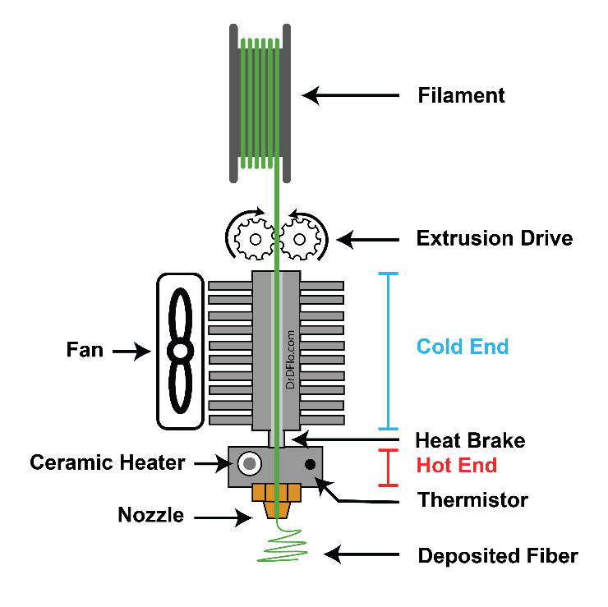
Picture 14: Extruder construction (The University of Texas at Arlington)
It consists of:
- Cold end: A gripping mechanism that pushes the filament against the heating element.
- Hot end: A heater and nozzle that melt the filament and precisely apply the material to the printing surface.

Print Surface (Work Plate)
This is the plate on which the 3D object is formed. It can be heated (important for materials such as ABS, PETG) or unheated (for simpler materials such as PLA). Good adhesion of the first layer to the printing surface is crucial for successful printing.

The printing surface can be made of various materials:
- Glass panel: Provides a smooth surface of the finished product and easy removal of the designs.
- PEI (Polyetherimide) surface: Provides excellent adhesion without the need for additional adhesives.
- Magnetic and flexible substrates: They facilitate the removal of models by allowing the substrate to be bended.
- Textured surfaces: They provide better adhesion to certain materials such as PETG and ABS.

Panning mechanism (X, Y, Z axis)
3D printers move along three axes:
- X-axis: Movement of the extruder left and right.
- Y-axis: The back and forth movement of the extruder or the movement of the printing surface.
- Z-axis: Raising or lowering the extruder (layer by layer).
These movements are made possible with the help of stepper motors, belt or threaded guides. Gear transmissions may also be used.
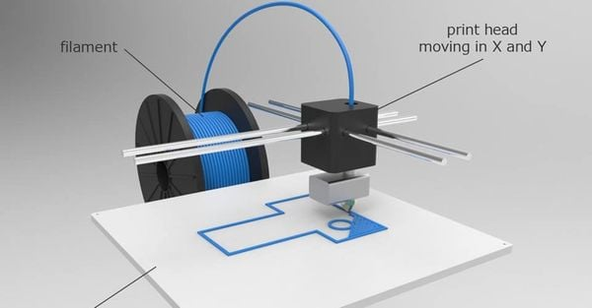
Picture 15: Scrolling mechanism (The University of Texas at Arlington)

Power supply and control electronics
Electronics control the operation of the printer, including the movement of the motors, the temperature of the extruder and communication with the user. Components include:
- Motherboard (control unit).
- Power supply for powering motors and heating elements.
- Display and control buttons or touchscreen to control the printer.
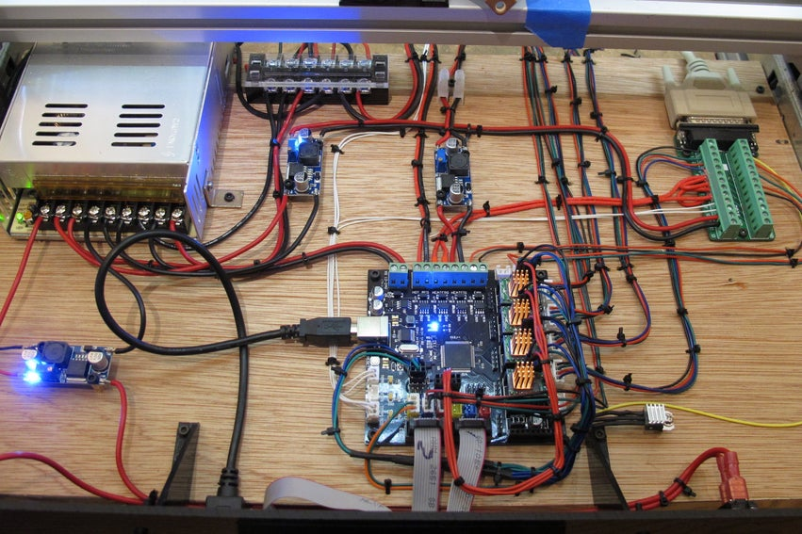
Picture 16: Power supply and control electronics (by Ivan Slinkar)

PREPARATION OF THE 3D PRINTER AND MATERIALS FOR PRINTING
3D printing is a revolutionary technology that allows the production of three-dimensional objects from various materials. Proper preparation of the 3D printer and materials is crucial for successful printing, as it ensures the accuracy, quality and strength of the finished products. In this section, we will go into the details of how to prepare a 3D printer and materials for printing in order to achieve optimal results.

Preparing the 3D printer

Selecting and Setting Up a Printer
There are several types of 3D printers, with FDM (fused deposition modeling) technology being one of the most common. Before you start printing, it is important to check that the printer is properly assembled and calibrated. For new printers, it is recommended to follow the manufacturer's instructions for installation and initial setup.

Calibrating the Print Surface
Accurate calibration of the print surface (bed leveling) is key to good adhesion of the first layer.
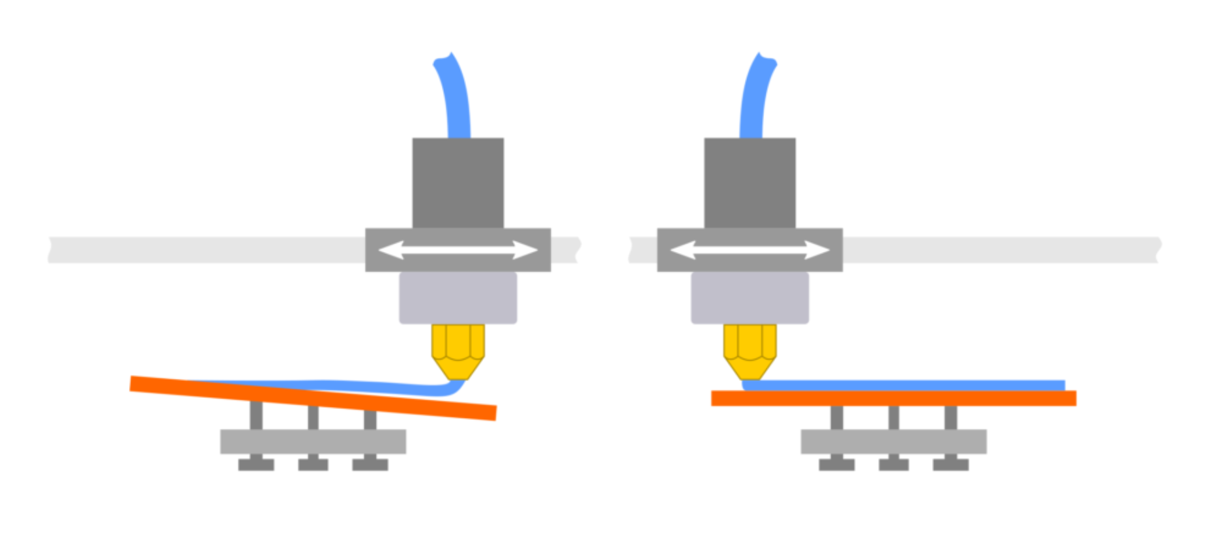
Picture 17: Calibration (calibration) of the printing surface (by Ivan Slinkar)
This can be done manually using a sheet of paper or automatically if the printer supports the automatic leveling function. The surface should be clean and evenly heated to prevent printing irregularities.
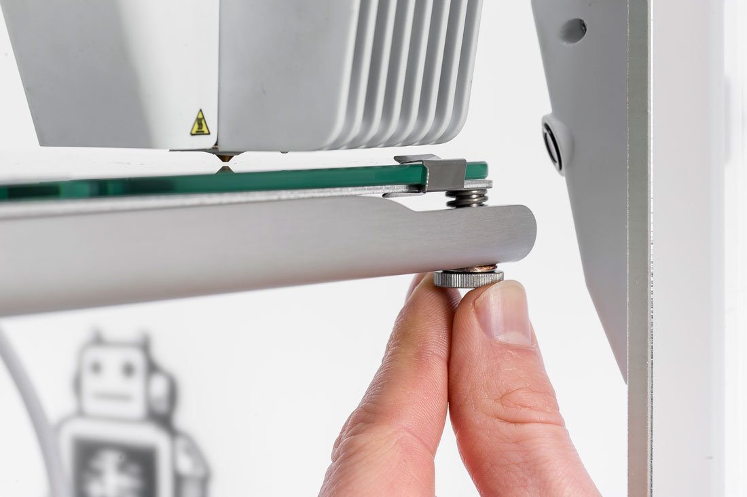
Picture 18: Manual calibration of the print surface (by Ivan Slinkar)

Adjusting the temperature of the nozzle and heating plate
Each material requires a specific temperature of the nozzle and heating plate. For example, PLA is printed at a temperature of around 200°C, while ABS requires higher temperatures, around 230-250°C, and a heated plate at around 100°C. Temperature settings greatly affect grip and print quality.

Extruder calibration
Accurate calibration of the extruder is important for uniform filament extrusion. If the extruder does not feed the correct amount of material, under- or over-extrusion can occur, which negatively affects the print quality.
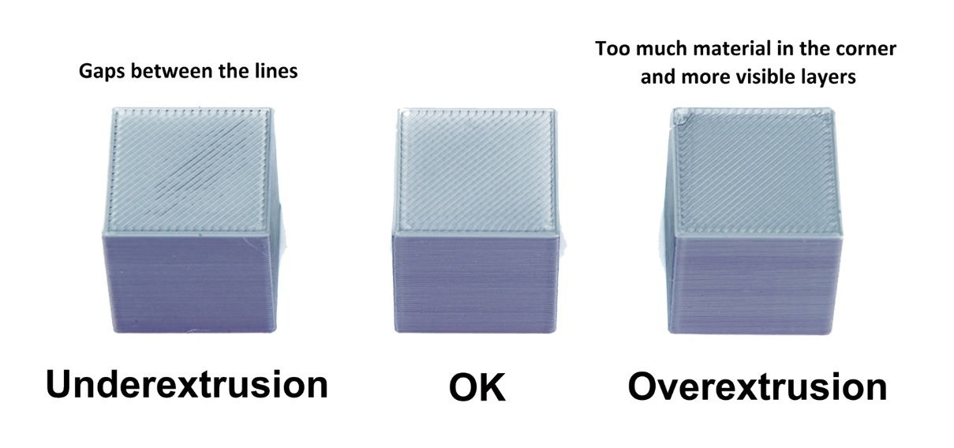
Picture 19: Under- or over-extrusion (Prusa Research)

Preparation of materials for printing

Filament selection
Choosing the right filament is key to successful printing. The most common materials for FDM printing are:
- PLA (Polylactic Acid): Easy to print, environmentally friendly, but fragile.
- ABS (Acrylonitrile Butadiene Styrene): Sturdy and resistant, but requires a heated print bed and good ventilation.
- PETG (Polyethylene Terephthalate Glycol): Combines the properties of PLA and ABS, high strength and moisture resistance.
- TPU (Thermoplastic Polyurethane): Flexible material suitable for printing flexible parts.
- Nailon: Strong and wear-resistant, but sensitive to moisture.

Proper storage of filaments
Moisture negatively affects the quality of filaments, as it can cause poor extrusion and bubbles in printed objects. It is recommended to store the filaments in hermetically sealed containers or bags with desiccant (silica gel).
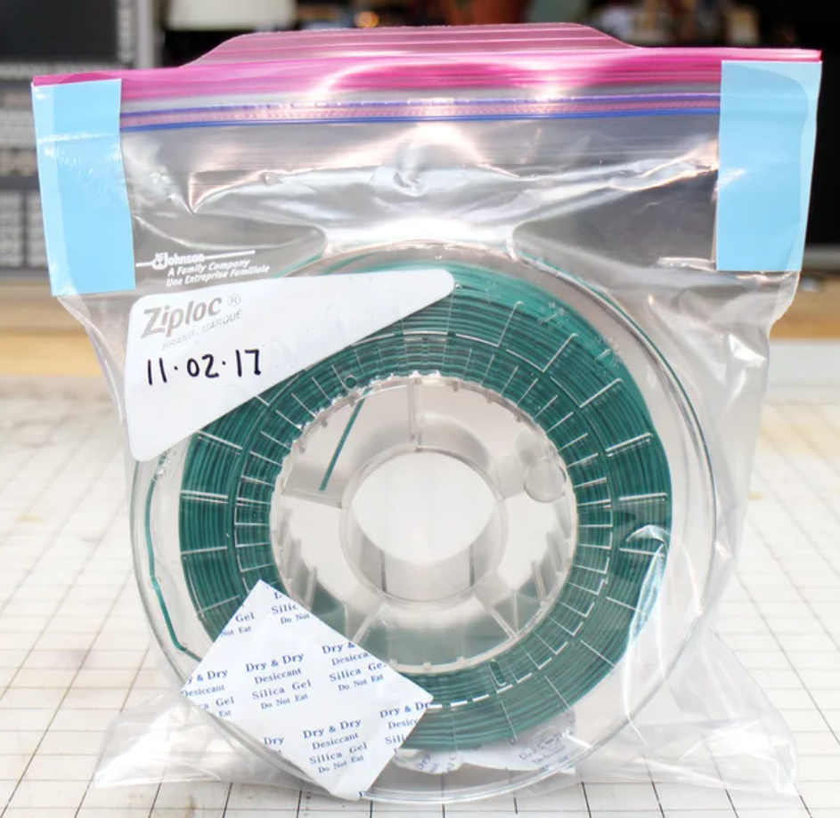
Picture 20: Proper storage of filaments (by Ivan Slinkar)

Preparing the filament for printing
It is recommended to dry the filament before printing, especially with materials such as nylon and PETG. Drying can be carried out in a dedicated oven or in an oven at low temperatures (about 50°C).

SAFETY PROCEDURES WHEN WORKING WITH A 3D PRINTER

3D printers have become an indispensable part of industry, education, and hobbies, but their improper use can pose security risks. To prevent accidents and ensure safe work, certain safety procedures must be followed.

Preparing the workspace
A suitable and safe working environment must be provided before using a 3D printer. The printer must be placed on a stable surface, away from flammable materials. It is recommended that the working area is well ventilated, as some types of filaments, such as ABS and nylon, can emit harmful fumes. It is also important that the user has access to the fire extinguisher and that there are no materials nearby that could cause a fire.

Personal protective equipment
When working with a 3D printer, it is recommended to use personal protective equipment. If the printer is used with the case open, it may come into contact with hot parts, such as the extruder nozzle, which can reach temperatures above 200°C. It is recommended to wear protective gloves when handling hot parts and safety goggles when cleaning the printer or removing material residues.

Proper handling of filament and materials
Different materials used in 3D printing have different properties and risks. PLA is generally safe to use, while ABS emits fumes that can be harmful with long-term exposure. Resins used in SLA printing can be dangerous to the skin and eyes, so it is necessary to use protective gloves and goggles and ensure good ventilation of the room.

Prevention of mechanical damage
3D printers have moving parts that can pose a danger to catching fingers or clothing. Before any intervention with the printer, such as changing the filament or cleaning the extruder, the printer must be turned off and the moving parts must be stopped. The printer should never be tampered with during operation, as fast-moving parts may cause damage.
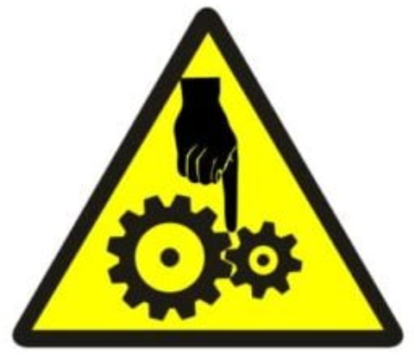
Picture 21: Symbol – Do not reach into the danger zone (by Ivan Slinkar)

Electrical safety
Most 3D printers operate at high voltage, so it's important to check that the cables are properly connected and that there is no visible damage to the power supply system. Use of unsuitable or damaged cables may result in electric shock or fire.
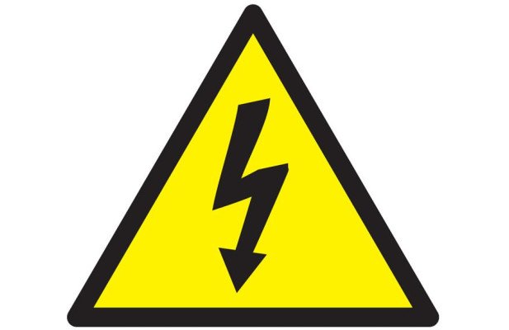
Picture 22: Symbol - Risk of electric shock (by Ivan Slinkar)
It is also recommended that the printer be connected to a surge protector and that it be disconnected from the mains after use.

Fire safety
Since 3D printers operate at high temperatures, there is a possibility of overheating and thus fire hazards. The user should always pay attention to the printer during operation and not leave it unattended. It is recommended to have a fire extinguisher nearby and use printers that have built-in safety sensors to control the temperature.
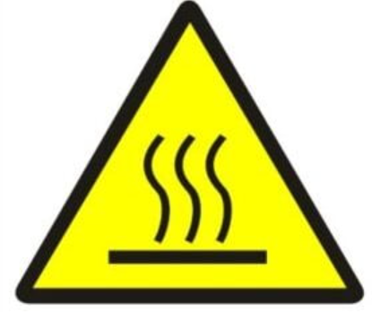
Picture 23: Symbol – Caution hot surface (by Ivan Slinkar)

Proper Printer Maintenance
Regular maintenance of the printer extends its lifespan and ensures safer use. This includes cleaning the extruder, checking the tightness of the screws, regularly lubricating the moving parts, and updating the software. It is also important to regularly check the quality of cables and connectors, as wear and tear can cause electrical problems.
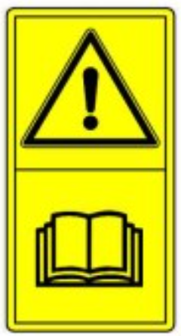
Picture 24: Hazard symbol – Follow the instructions (by Ivan Slinkar)

Security when removing printed objects
After the printing is completed, the printed object should be carefully removed, as the working surface may still be hot. It is recommended to use a spatula or other suitable tool to prevent injury to the fingers or abrasions. When printing with resin, printed objects must be properly cleaned and hardened in accordance with safety guidelines.

Responsible waste management
3D printing can cause waste material that needs to be disposed of properly. Biodegradable materials such as PLA are less harmful to the environment, while ABS and resins must be disposed of in accordance with local hazardous waste regulations. It is recommended to recycle filament residues and use environmentally friendly materials.

Handling Hazardous Substances When Cleaning the Printer
When cleaning a 3D printer, it is often necessary to use chemical solvents such as isopropyl alcohol, acetone or specialized resin cleaners. These agents can be flammable and harmful when in contact with the skin or inhalation of fumes. Therefore, when handling them, it is necessary to wear protective gloves and a mask, as well as ensure good ventilation of the room. Chemical agents should be stored in original, tightly closed containers, away from heat sources or open flames. After using these substances, it is necessary to thoroughly clean the surfaces and wash your hands.
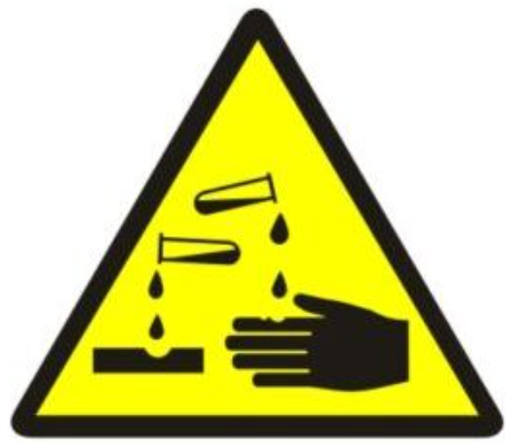
Picture 25: Symbol – Caution Hazardous Substance (by Ivan Slinkar)

Teaching and raising awareness of users
Every user of a 3D printer must be properly trained in its safe use. This includes knowledge of how to start and stop the device correctly, how to handle materials, and emergency procedures. Organizing workshops and safety training can help to increase safety and better understand the risks of 3D printing.

Safety when working with a 3D printer is crucial to prevent accidents and ensure the long life of the device. With proper preparation of the workspace, the use of protective equipment, regular maintenance and responsible handling of materials, every user can reduce risks and safely enjoy the benefits of 3D printing.

PARAMETER SETTING AND PRINT MONITORING

3D printing is a complex process in which the correct setting of parameters is crucial for a quality product. Different materials and models require different settings, so it's important to understand how to adjust parameters in the software (slicer) and monitor printing to identify and fix any problems.

Setting Print Parameters

Basic Printing Parameters
When setting up printing, it is necessary to take into account several key parameters that affect the final quality of the product. The most common parameters include:

Print speed
The print speed determines how fast the print head moves. Too fast a speed can cause problems with the adhesion of the layers, while too slow a speed increases the printing time. Recommended values:
- PLA: 40–60 mm/s
- ABS: 30–50 mm/s
- PETG: 40–60 mm/s
- TPU: 20–40 mm/s (due to the elasticity of the material)

Speed also affects the quality of details, as printing shake or impaired dimensional accuracy may occur at higher speeds. The correct choice of speed is especially important for models with thin walls or fine details. However, it also depends a lot on the construction of the 3D printer, so the recommended values are only indicative.
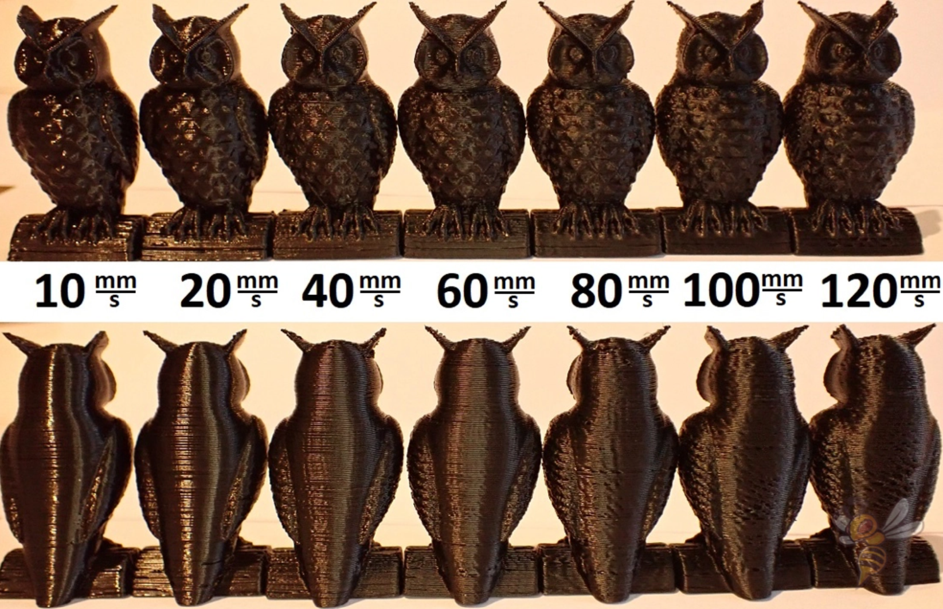
Picture 26: Print quality at different print speeds (Innovative Drive Systems)

Print Temperature
The temperature of the nozzle and the heating table is adjusted depending on the material:
- PLA: 190–220 °C (table: 50–60 °C)
- ABS: 220–250 °C (table: 90–110 °C)
- PETG: 220–250 °C (table: 70–90 °C)
- TPU: 200–230 °C (table: 40–60 °C)

Improper temperature can cause problems such as poor adhesion, loose layers or clogging of the nozzle. It is important that the temperature is adjusted according to environmental conditions such as humidity, air currents and filament quality.

Layer thickness (layer height)
The thickness of the layer determines the resolution of the print. The smaller the layer, the smoother the surface will be, but the printing time increases. Recommended values:
- High quality: < 0,2 mm
- Standard quality: 0,2 mm
- Fast printing: > 0,2 mm
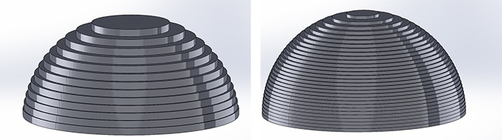
Picture 27: Different layer thicknesses (Innovative Drive Systems)
A larger layer thickness increases the printing speed, but at the same time reduces the detail and smoothness of the model's surface. It is important to find the right ratio according to the requirements of the model.

Model Fill (Infill)
The filler determines the density of the internal structure of the model. More filler means more strength, but also longer printing time and more material consumption.
- Decorative models: 10–20%
- Functional parts: 40–60%
- Very strong parts: 80–100%
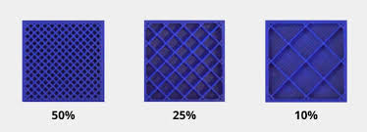
Picture 28: Different filler density (Innovative Drive Systems)
The type of filler (hexagonal, grid, linear, etc.) affects the durability and consumption of the material. For heavier or loaded parts, it is recommended to choose more complex filler structures.
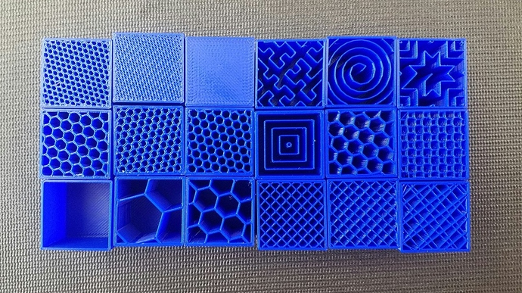
Picture 29: Different types of fillers (Innovative Drive Systems)

Support and cooling settings
Supports are necessary in models with overhangs. Slicer allows for different types of supports, such as line or tree supports. Cooling is particularly important in PLA, as it allows the material to solidify faster and prevents deformation.
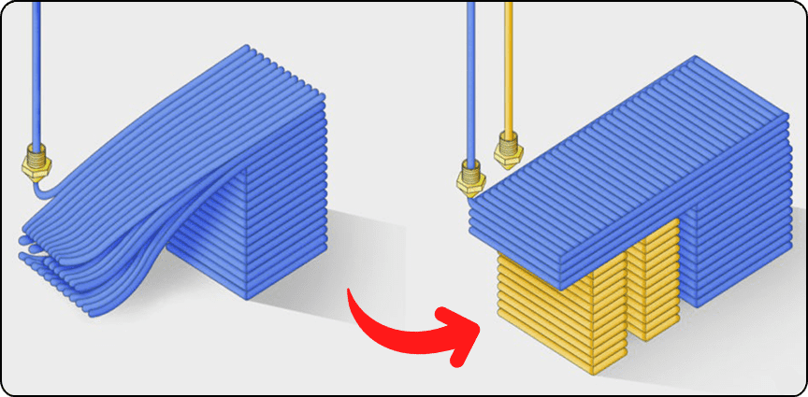
Picture 30: "Support" (Innovative Drive Systems)
Proper cooling settings help prevent deformation of models and improve the quality of details. With ABS, cooling should be reduced, as rapid cooling can cause the model to crack.
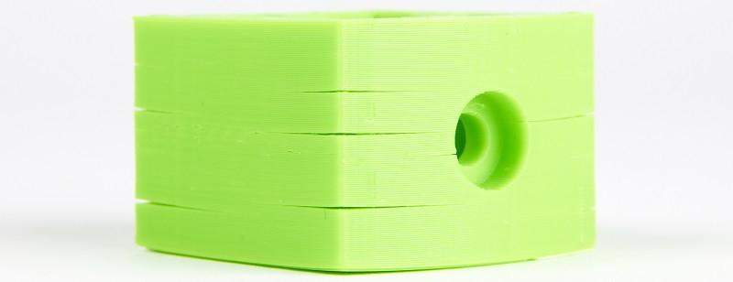
Picture 31: ABS cracking due to excessive cooling during printing (Innovative Drive Systems)

Print monitoring and problem detection
During printing, it is crucial to constantly monitor the process, as various problems may arise.

Possible problems during printing

Poor adhesion of the first layer
If the first layer does not adhere to the printing table, printing may fail. Possible causes and solutions:
- The table is not leveled correctly – Re-leveling the printing plate
- Too far or too far from the nozzle – sets the distance of the nozzle
- Inappropriate table temperature – Temperature increase
- Under-compressed filament against the table – Smaller distance between nozzle and table
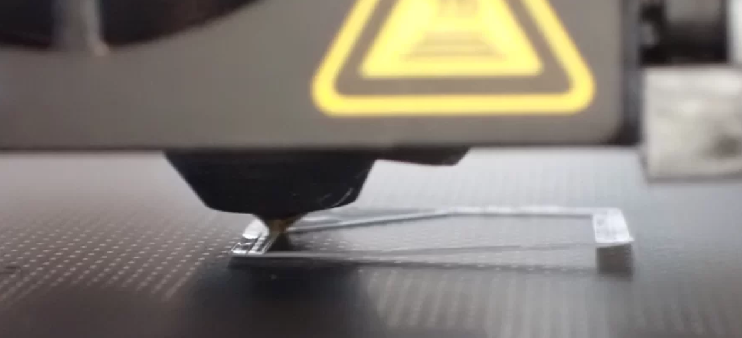
Picture 32: Poor adhesion of the first layer (by Ivan Slinkar)
Good adhesion of the first layer is the key to successful printing, so it is recommended to use help in the form of adhesive sprays or special printing substrates.
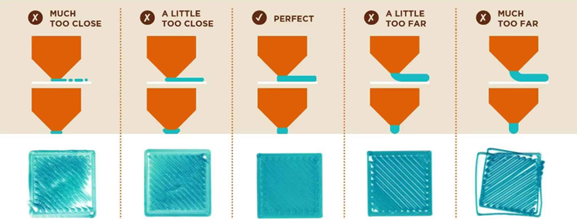
Picture 33: The distance of the table from the nozzle (Prusa Research)

Deformation and warping
Especially with ABS and PETG, the edges can rise due to uneven cooling. Solutions:
- Using the Heatbed and Printer Cover
- Increasing adhesion with the help of adhesives or special substrates
- Using the brim or raft function
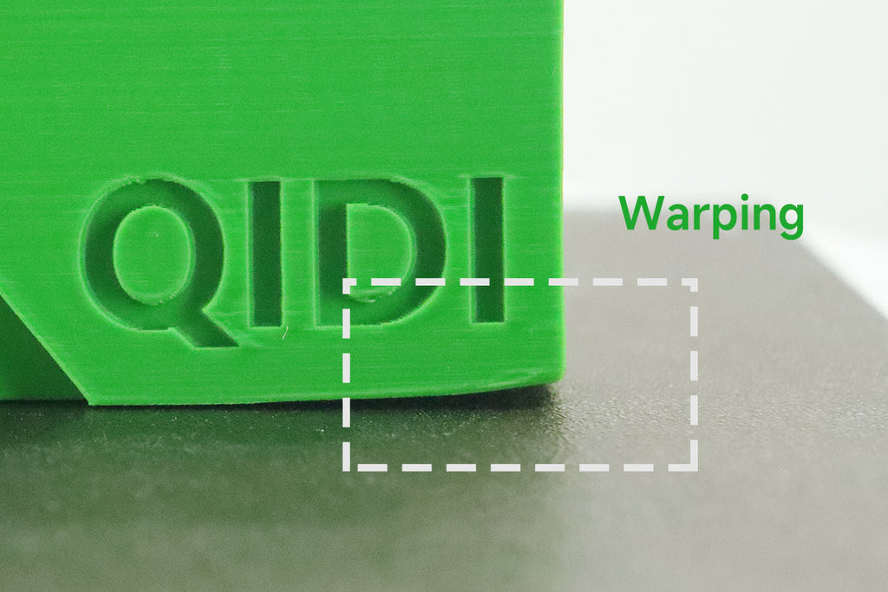
Picture 34: Wrapping (Prusa Research)
Deformations can affect the functionality of the model and reduce its mechanical strength.

Stringing & blobs
If the filament leaks out during the movements of the print head, threads may form. Possible causes and solutions:
- Printing Temperature Too High → Temperature Reduction
- Incorrectly set retraction → Increase in retraction length (retraction)
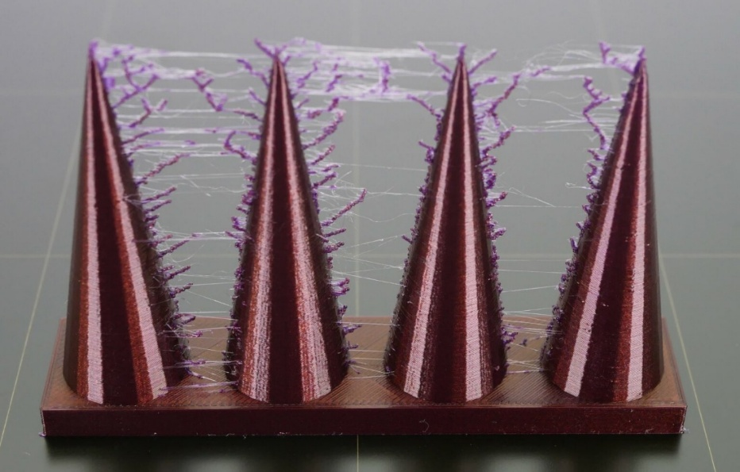
Picture 35: Threading "stringing" (Prusa Research)
Stringing often occurs with flexible materials such as TPU, where the retraction and speed of movement need to be particularly precisely adjusted.

Clogging of the nozzle
If the filament stops coming out, the nozzle may be clogged. Possible causes:
- Use of impure filament
- Printing temperature too low
- Too compressed first layer
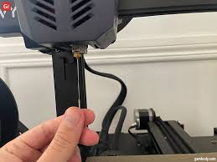
Picture 36: Cleaning the nozzle with a needle (by Ivan Slikar)
The solution is to clean the nozzle with a special needle or perform the "cold pull" method.

Adjust settings during printing

In some cases, it is possible to adjust the settings during printing:
- Changing the Real-Time Print Temperature
- Adjust the head speed
- Fan cooling setting

Modern 3D printers allow you to dynamically adjust settings, which can help improve the quality of the final product.

Proper parameter setting and accurate printing monitoring are key to successful 3D printing. By understanding the settings and quickly identifying problems, we can achieve better results and reduce material waste and costs. Users of 3D printers must learn to identify the causes of the most common errors and eliminate them on an ongoing basis, as even a small adjustment of parameters can significantly improve the quality of the final product.

3D PRINTING AND FINISHING OF PRINTED MATERIALS
3D printing is an innovative process of making three-dimensional objects from digital models. This technology makes it possible to quickly produce prototypes, functional parts and finished products. 3D printing is widely used in industry, healthcare, architecture, education, and other fields, as it allows for affordable and flexible manufacturing. For the successful implementation of 3D printing and finishing of printed materials, it is necessary to follow several key steps that ensure the quality and durability of the final product.

Implementation of 3D printing

Product printing
Before the start of 3D printing, it is necessary to prepare a digital model in a suitable format, most often STL or 3MF format. The model is then processed with software (slicer), where printing parameters are determined, such as:
- Layer height
- Print speed
- Print head and work plate temperature
- Support structure
- Infill
After setting the parameters, the file is transferred to the 3D printer, which begins the material layering (FDM) process. During printing, it is crucial to monitor the process to prevent errors such as layer offsets, nozzle blockages, or poor adhesion to the worktop.

Monitoring the printing process and detecting errors
During the printing itself, various problems can arise that affect the quality of the final product. Some of the most common mistakes and possible actions are:
- Lack of adhesion: The use of an adhesive base, an increase in the temperature of the worktop, the use of "raft" or "brim" options.
- Clogged nozzle: Cleaning or replacing the nozzle, using filaments without impurities.
- Stringing: Adjust temperature and retraction settings.
- Uneven layers: Checking belt tension and calibrating the axis.
- Warping: Use of a closed print space, heated plate and proper cooling of the layers.
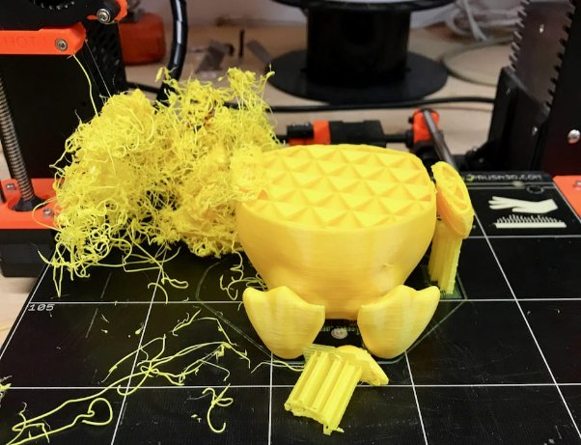
Picture 37: Printing error detection (by Ivan Slinkar)
Timely detection and elimination of these defects ensures a high-quality printed product. Regular maintenance of the printer is also important, as wear and tear on components can cause poorer printing.

Removing the Product from the Printer
After printing, the model must be carefully removed from the print base. For hardy models, a spatula or heating of the substrate can be used for easy removal.

Use the Product Removal Tool
After the printing is completed, the product must be carefully removed from the printing plate. Various tools are used for this, such as:
- Scraper for careful separation of the product
- Heat treatment for easier disposal
- Flexible print beds for easier disposal
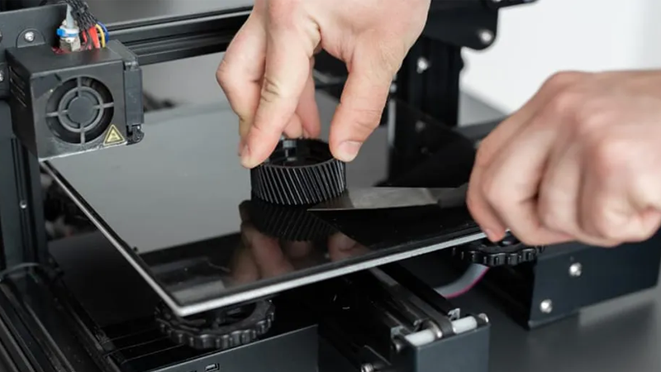
Picture 38: Removing the product with a scraper (by Ivan Slinkar)
When disposing, the key is to prevent damage to the product and the printing plate itself. Some printers allow the use of magnetic pads that make it easier to remove the product.

Printer Cleaning Procedures After Printing
After removing the model, the 3D printer must be properly cleaned:
- Removing the remaining material from the nozzle
- Cleaning the printing plate
- Inspection of moving parts and lubrication
- Regular calibration for accurate performance
- Checking electronics and fans for proper cooling
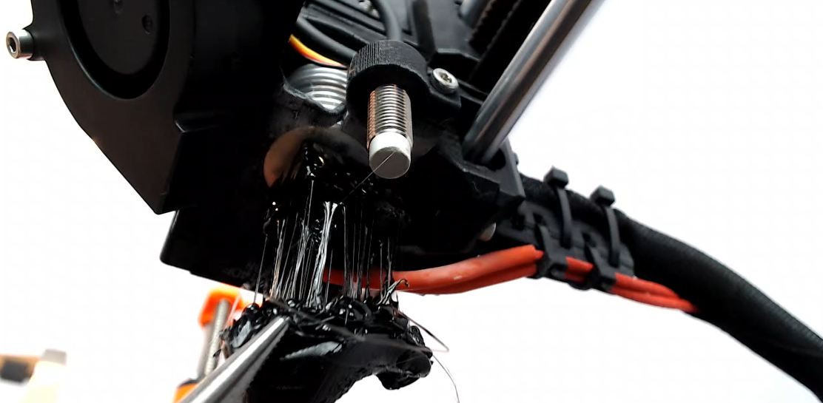
Picture 39: Nozzle needs cleaning (by ivan Slinkar)
These processes ensure a longer printer life and better quality for future prints.

Completing the model
After printing, additional processing of the model is often required to improve its functionality and aesthetics.

Mechanical and chemical finishing techniques
Mechanical processing includes:
- Sanding to smooth the surface
- Cutting excess support structures
- Gluing parts together (in larger models).
- Drilling and dimensional adjustment
Chemical processing includes:
- Acetone smoothing for ABS materials
- Epoxy coatings for increased strength
- Heat treatment to improve the properties of the material
To improve the visual appearance of the models, painting and varnishing are used, as well as chemical treatment (e.g. smoothing ABS with acetone vapours).
In SLA printing, additional leaching of the models in isopropyl alcohol is required to remove excess resin, and subsequent UV curing to improve the strength of the model.

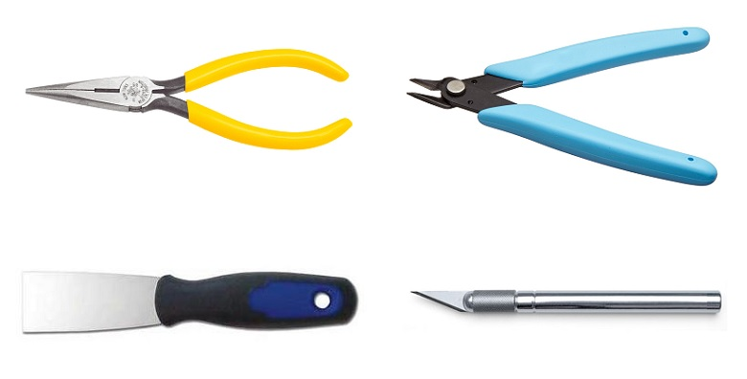
Picture 40: Product Cleaning Tools (by Ivan Slinkar)
With these techniques, we can achieve high-quality and professionally processed products that are suitable for exhibition models, products for sale or use in professional applications.
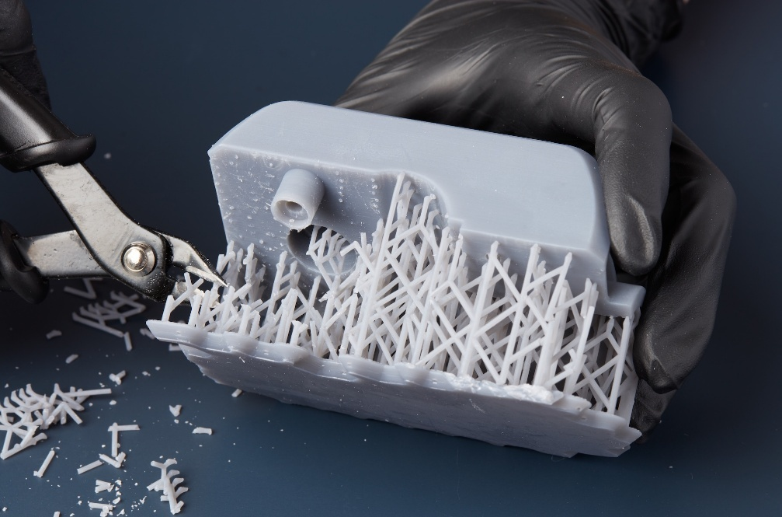
Picture 41: Removing Support (by Ivan Slinkar)
Successful 3D printing requires proper model preparation, careful monitoring of printing and professional product finishing. With proper operation and maintenance of the printer, we can achieve optimal results and a longer life of the equipment. However, the refinement of the model allows you to improve both the functional and aesthetic qualities of the finished products. 3D printing is constantly evolving, so it is important to keep up with new technologies, materials and techniques that enable even better and more efficient results.

CALCULATION OF THE COST OF 3D PRINTING

3D printing is an innovative technology that allows for the production of a variety of custom items, but it is important to understand the costs associated with this process. The cost of 3D printing depends on several factors, such as material consumption, printing time, electricity consumption, wear and tear on the printer, and any additional costs such as repairs and post-processing.

Material cost
The largest part of the cost of 3D printing is the material used in printing. The most common materials are:
- PLA, ABS, PETG – filaments for FDM printers
- Resin – for SLA printing
- Metal or composite materials – for industrial 3D printing
The price of filament usually ranges between €20 and €50 per kilogram, while resin is more expensive, often between €50 and €150 per litre. Material consumption can be calculated based on the mass of the printed component, which is given by the software for model preparation (slicer). The formula for calculating the cost of materials:
$$Material costs=used material(g)×\frac{material costs(\frac{€}{kg})}{1000}$$

Energy costs
3D printers run for hours or even days, so it's important to consider the cost of electricity. The average FDM printer consumes about 100-250 watts per hour, while SLA printers consume less power. Formula for calculating electricity costs:

$$Electricity costs=printer power×printing time\left(h\right)×electricity price(€/{kWh)}$$

For example, if the printer operates for 10 hours at 200 W (0.2 kW) and the electricity price is 0.15 EUR/kWh, the costs are:
$$0,2kW×10h×0,15€/{kWh=0,30€}$$

Printer wear costs
Over time, printer parts wear out, which means that maintenance costs must be taken into account. Some of the most frequently replaced parts include:
- Nozzles and heating units
- Bearings and pulleys
- Print platforms
- Ventilation filters (for SLA printing)
It is usually estimated that the cost of printer wear and tear is between €0.50 and €2 per print.

Post-processing costs
After printing, additional processing is often required, such as:
- Removal of supports
- Grinding and polishing
- Painting or varnishing
- UV curing (in SLA printing)
The cost of post-processing depends on the complexity of the model and the techniques used and can range from a few cents to several euros per piece.

Calculation example
Let's say we want to print an object with 100 g of PLA filament (price 25 €/kg), the printer consumes 150 W and prints for 5 hours, the maintenance costs are 1 EUR per print, and post-processing is 2 EUR. The price of electricity is 0.15 €/kWh.
$$Material costs=100g×\frac{25€/{kg}}{1000}=2,50€$$
$$Electricity costs=0,15kW×5h×0,15€/{kWh}=0,11€$$
$$Wear costs=1,00€$$
$$Post-processing costs=2,00€$$
$$Total cost of 3D printing=2,50€+0,11€+1,00€+2,00€=5,61€$$
Calculating the cost of 3D printing is crucial for assessing the economics of production and optimizing processes. Taking into account the costs of materials, electricity, printer wear and post-processing allows for more accurate price estimates for individual projects and better cost planning.

MODELING SIMPLE 3D MODELS WITH ONSHAPE

Onshape is a modern software solution for computer-aided design (CAD), which also allows you to manage and view product data. Unlike classic modelers, Onshape works completely in the cloud, which means that it does not require software installation. All you need is access to a web browser and an internet connection. In addition, Onshape is adapted for use on smartphones and tablets, which allows you to work anywhere and anytime.
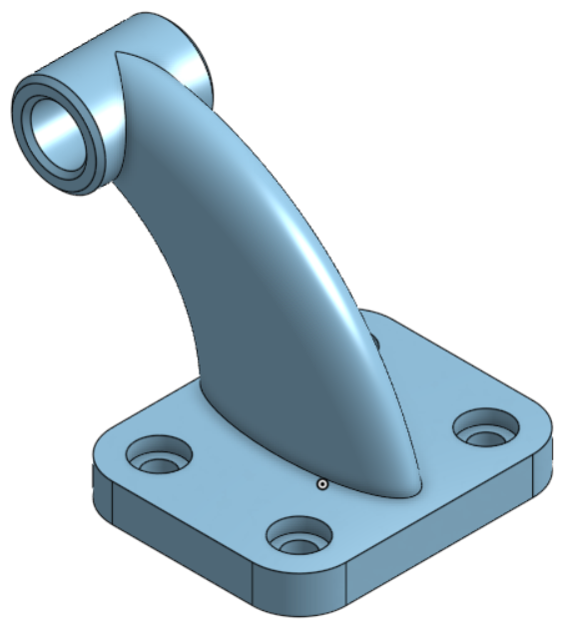
Picture 42: 3D CAD Model (by Boštjan Škrabec)

Modeling is done using tools from the toolbar, while models can be simultaneously viewed and edited in the graphics window.
This Onshape modeling guide is designed as a quick guide, suitable for both beginners and experienced 2D and 3D modeling users.

10.1 Selecting a web browser and opening a user profile
Onshape can be used with all modern web browsers, such as: Google Chrome, Mozilla Firefox, Microsoft Edge, Apple Safari and others.
We access the Onshape application via a web browser at www.onshape.com .
To use it, you must first open a user profile at https://www.onshape.com/en/sign-up, through which we will later access the Onshape services. All data and models are linked to this profile.
After completing the registration form, you must confirm your user profile via email.
For faster access, you can later create a shortcut to the login page: https://cad.onshape.com/signin .
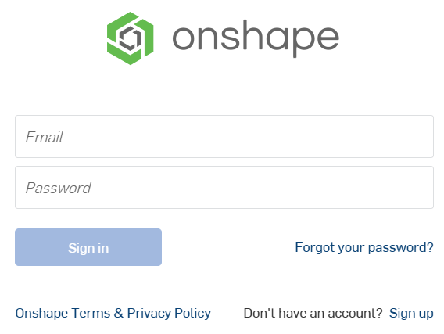
If you need a profile intended for teachers, you can do so at the following link:
https://www.onshape.com/en/education/#form-container

User Interface Settings
After confirming the user profile, it is necessary to set a password for secure access.
After confirming the password, it automatically logs you into the application and opens a window in which we edit the basic user settings. Under point 1, we set the units. I suggest setting the units for length to millimeters, for acceleration to meters per minute per square, for angle to degrees and angular velocity to degrees per second.
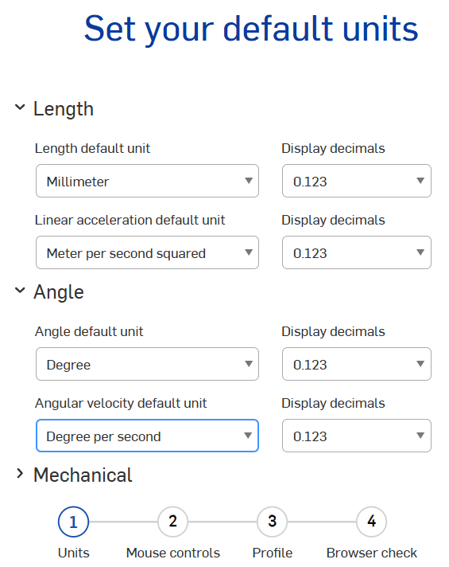
Under point 2, we select the mouse operation settings, where we can choose between settings for the Onshape, Creo, Solidworks, NX or AutoCAD program.
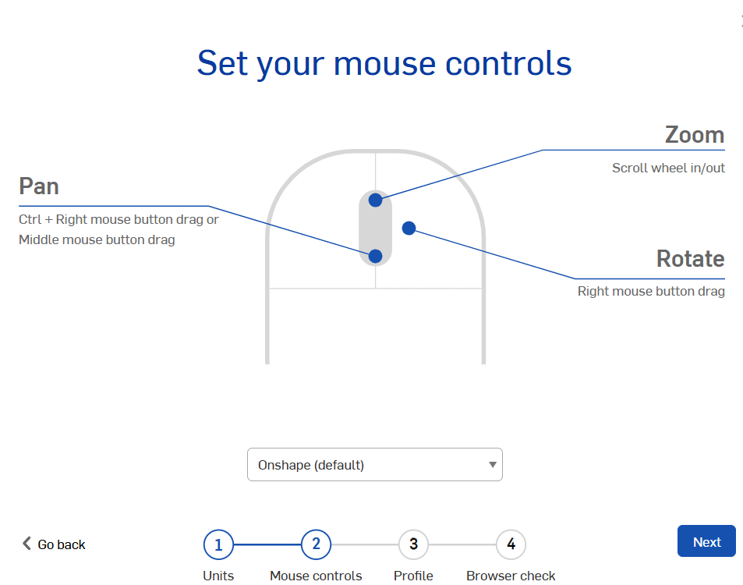
Under point 3, we can set our username and change our user icon.
Under point 4, Onshape also checks the suitability of the web browser we are using.
With this, our account and interface are set up. All of the above and many other settings can be changed later by clicking on the username in the upper right corner of the window and selecting My account.
By clicking on the Onshape icon in the upper left corner of the window, we can always return to the main page of the user interface.
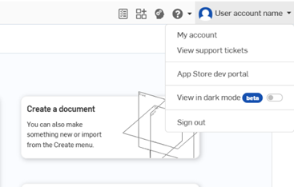
Account settings

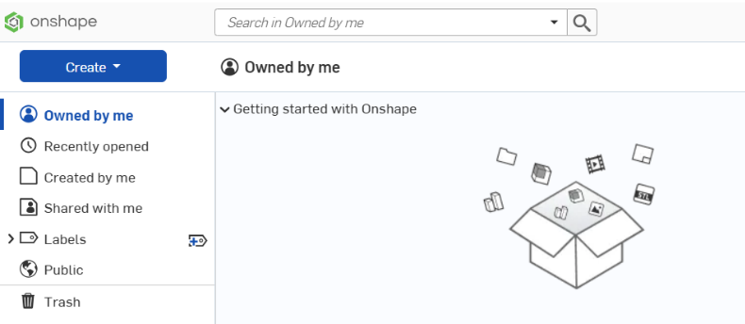
Return to the home page
Files opened recently
Shared content
Deleted files
Search bar

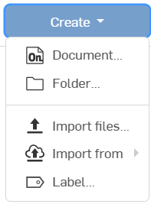
Creating a new document

We create a new document by clicking on the blue Create icon. A drop-down menu opens with options to create a document, folder, import files or labels, with which we can mark models for better structure. We select the document and create it. It is necessary to specify a name and a storage location, and there are no restrictions with noisemakers.

The “Document” in Onshape combines 3D models, assemblies, and drawings into a single environment (document). Data is saved automatically as you work, so there is no need to save manually. In the event of a power outage or internet connection failure, your data is safe and you don’t lose your work.
In Onshape, 3D models, assemblies, and drawings don’t have their own file format (such as .prt, .sldprt, etc.), but they can be exported to various standard formats such as STEP, ACIS, Parasolid, STL, SolidWorks, and others.

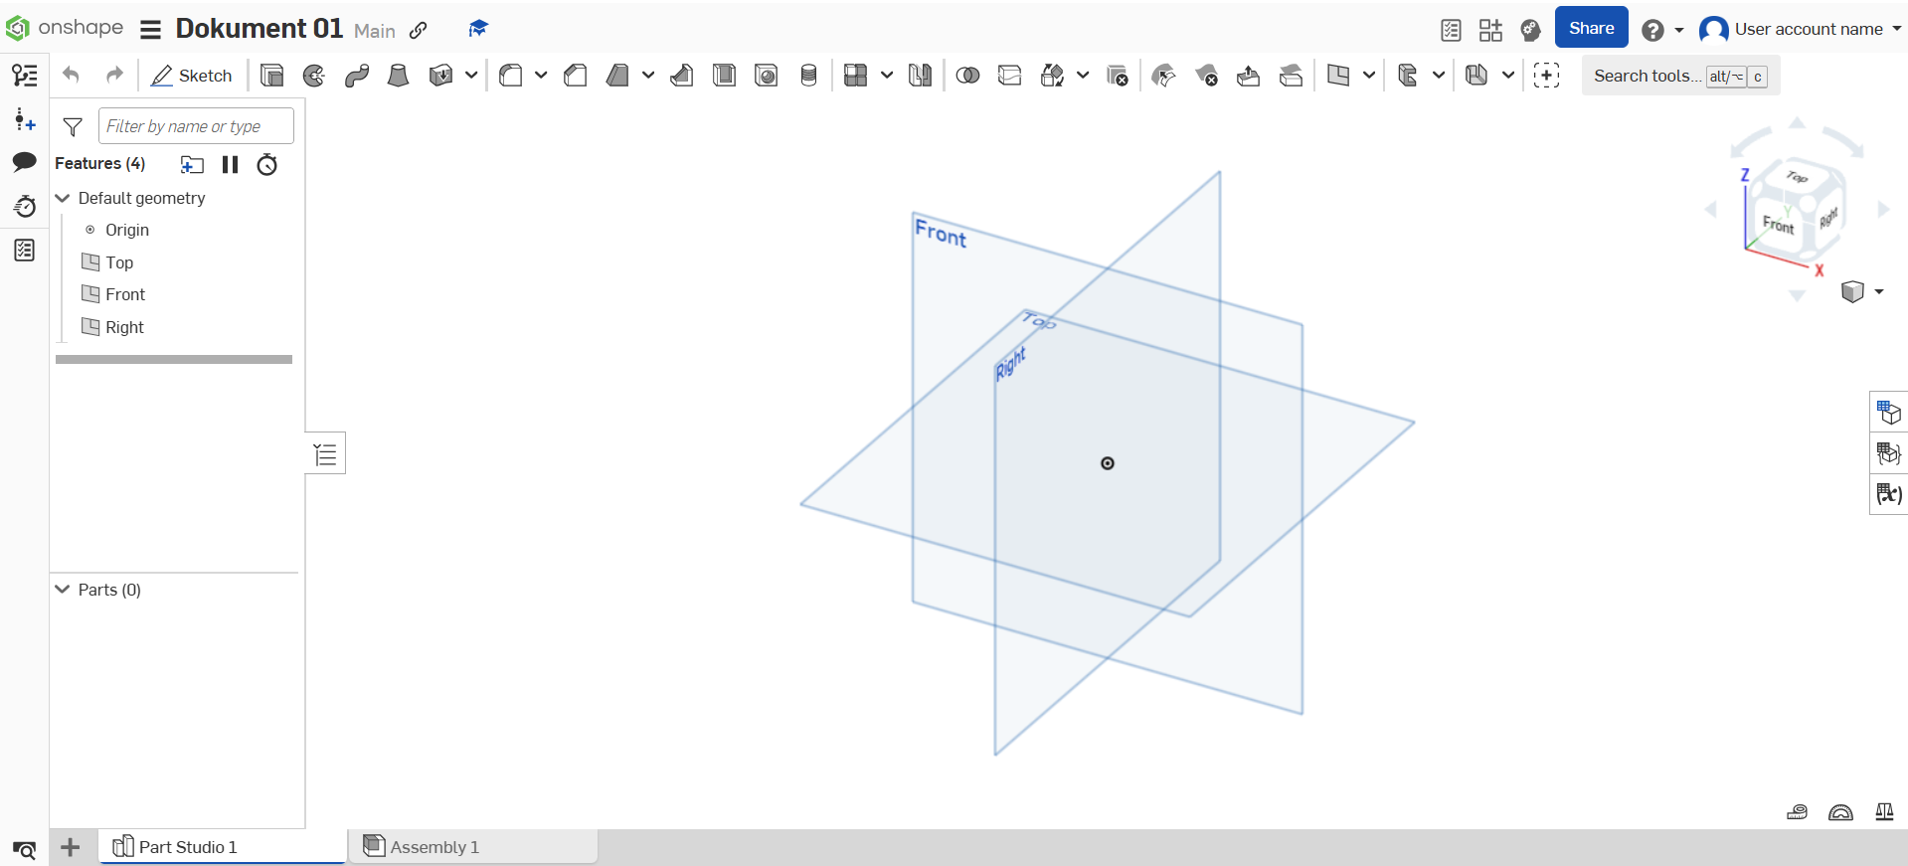
Parts of a document

For a better user experience, you can switch to full-screen mode within the browser, which provides a larger work area. You can turn it on or off by pressing the F11 key on your keyboard.

Onshape document
The document workspace is divided into a toolbar, a graphics window, a model tree window, and a navigation bar.
Toolbar

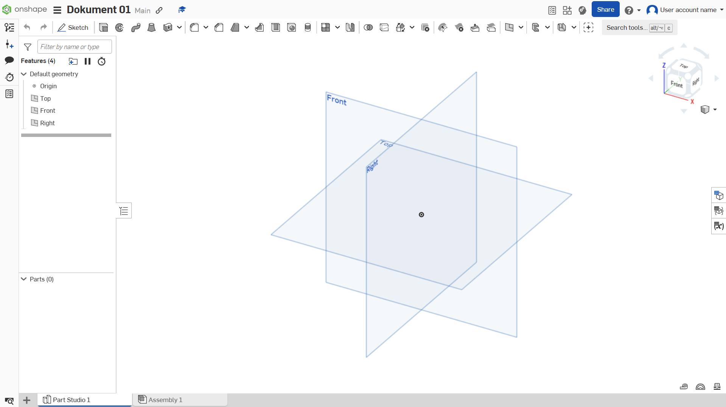
Model
tree
window

Graphical window

Navigation bar

The toolbar contains all the features that can be used to create models. They are activated by clicking on them and entering the appropriate parameters for designing the model.
The graphics window interactively displays the current state of the model and allows you to orient and move models or assemblies to the desired position. The manipulation methods depend on the mouse settings selected within the user account. The basic Onshape setting is as follows:
- Rotate – Hold down the right mouse button and move the mouse.
- Pan – Hold down the middle mouse button and move the mouse.
- Zoom – Rotate the mouse wheel.
The model tree window contains all the components used in the creation of the model, arranged in chronological order (model history). Each new model has a preset origin and three basic planes. At the bottom of the tree is a time-lapse slider that allows you to return to a previous state of the model - moving the slider back temporarily disables later operations.
To edit an individual component in the model tree:
- Double-click on it to open it for editing, or
- Right-click and select "Edit" to adjust its settings.
In the navigation bar, we notice that after creating a new Onshape document, the Part Studio tab opens first. Part Studio is a working environment where we create models. In it, we can create one or more models, which we then combine into an Assembly, which is located in the tab on the right.

Within an Onshape document, we can add new models, assemblies, drawings, and folders, where we can move all the aforementioned elements in an organized manner. For a better overview of the navigator content and the ability to filter, click the Tab manager icon in the lower left corner.

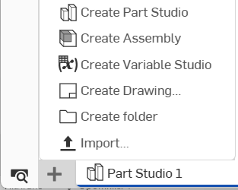
Create a new piece in this document
Create a new set in this document

Create a new drawing in this document
Create a new folder in this document
Entering Already Crafted Items

Tab manager

If you want to import a model, assembly, or drawing that you have saved on your computer into a document, you can do so by clicking the Import icon. Onshape supports formats from various modeling tools, such as Creo, Catia, SolidWorks, NX, Inventor, and others. In addition, you can also import PDF documents, images, and videos, which you can then open directly within the document in the modeling tool.

Sketch
There are several different approaches to creating a model. The most common approaches are defined by sketching a cross-section of a component and then creating a three-dimensional body using operations such as extrusion, rotation, etc.
In the following, we will take a closer look at the process of creating a sketch in Onshape.
A sketch consists of geometric elements (lines, curves, etc.), boundary conditions, and dimensions. The key to a correct sketch is that it is fully defined, meaning that all of its elements are specified using angles and relations.
In Onshape, the state of a sketch is visually displayed using different colours:
- Black – sketch is fully defined.
- Blue – sketch is partially defined or undefined.
- Red – sketch contains an error or is overdefined
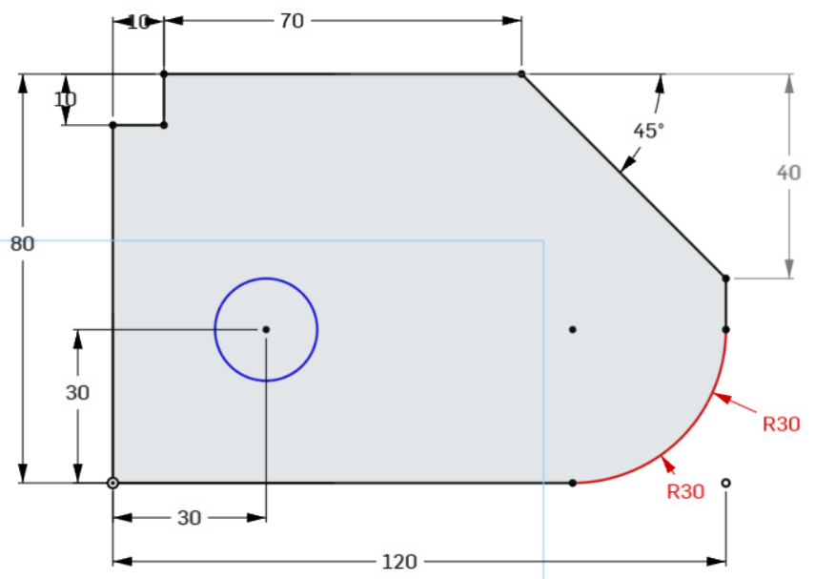
Picture 43: Sketch (by Boštjan Škrabec)

To create a sketch, we need a plane that allows us to draw two-dimensional objects.
In addition to base planes, we can also create sketches on solid surfaces. If the surface of a solid is completely flat, we can sketch directly on it, without creating an additional reference plane – simply select a flat surface and create a new sketch using the appropriate command.

The Sketch command is located on the toolbar. Clicking it opens a command window that asks you to select a drawing plane.
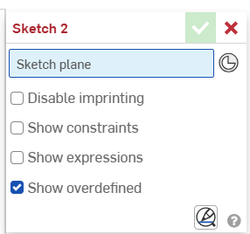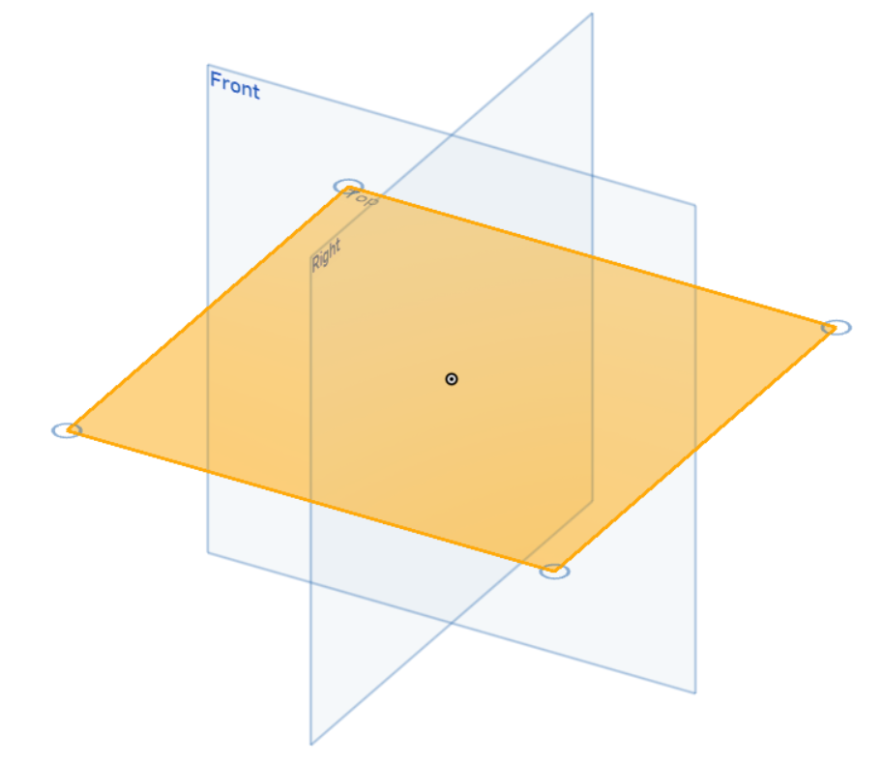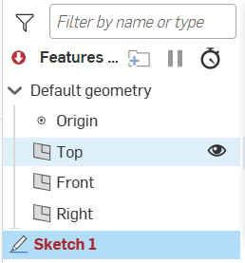

To start sketching, select one of the predefined planes, for example the Top plane. The selection can be made in two ways:
- By clicking with the left mouse button directly in the graphical interface.
- By selecting a plane in the model tree.
When we select a sketching plane, the toolbar changes and the 2D sketching tools appear.
These include basic geometric entities such as:
- Line
- Rectangle
- Circle
- Arc
- Polygon
- Spline
In addition to geometric entities, there are also tools for dimensioning and adding relations that allow you to precisely define the sketch.
The process of drawing sketch building blocks is intuitive and allows you to quickly create basic geometric entities.
While sketching, Onshape offers auxiliary alignments and relations that facilitate the precise placement of elements and ensure the geometric correctness of the sketch.
In the command window of the sketch building block, you can enable the display of relations (constraints) that define the relationships between elements. These relations remain valid even if you later change the dimensions of the elements.
There are several types of relations, each of which is indicated by its own icon that appears next to the element in the sketch and in the toolbar. Relations can be added manually or Onshape suggests them automatically while sketching.

If we want to delete a relation, we can do it in two ways:
- Click on it and press the "Delete" key
- Right-click and select the delete option
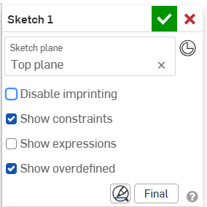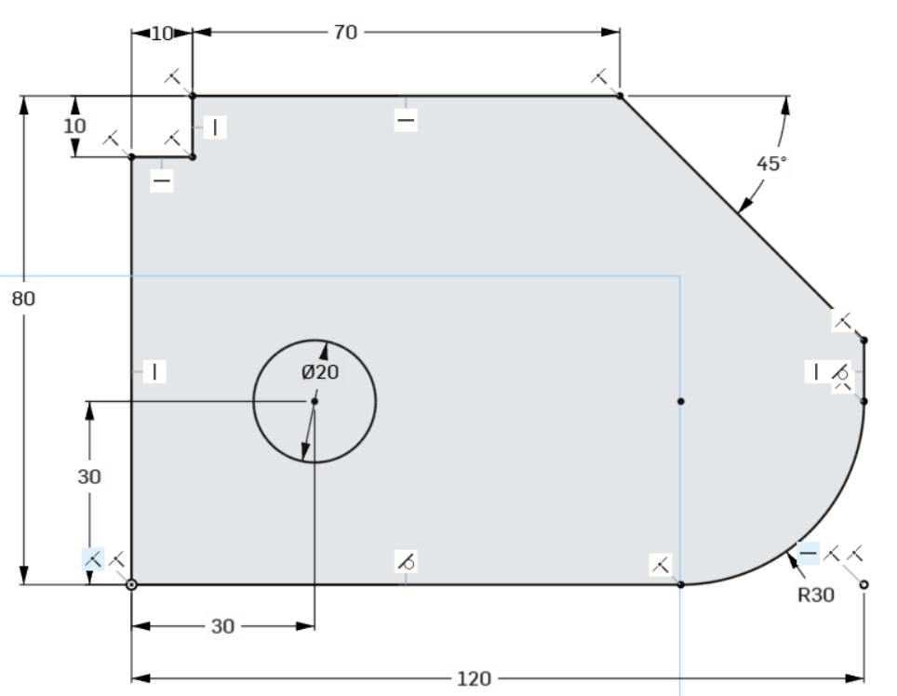

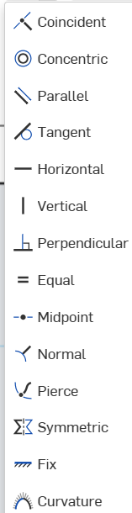
Relations (Constraints) in Onshape:
    - Coincident – specifies that the element's origin is located at the selected point.
    - Concentric – forces circles or arcs to share the same center.
    - Parallel – keeps the lines always parallel.
    - Tangent – specifies that an element is tangent to a circle or arc.
    - Horizontal / Vertical – constrains the line to always remain horizontal or vertical, preventing it from being placed at an angle.
    - Perpendicular – ensures that two lines are always perpendicular.
    - Equal – determines that two elements are the same size.
    - Midpoint – places the element so that it has its center at the selected point.
    - Normal – provides a perpendicular (orthogonal) orientation of a line to a curve or a curve to a plane.
    - Pierce – forces a point or line to coincide with the intersection of its sketch plane and an arbitrary curve that is not in the same plane.
    - Symmetric – defines two elements as symmetrical about the selected line.
    - Fix – fixes a point or element in space, preventing it from moving unless the relation is removed.
    - Curvature – creates smooth curve transitions between curves and other selected elements.

PRACTICAL MODELING TASKS WITH ONSHAPE

Task 1
Let's start by drawing a simple sketch, as shown in the image below. We create the sketch in the Part Studio document we created earlier (the first document).

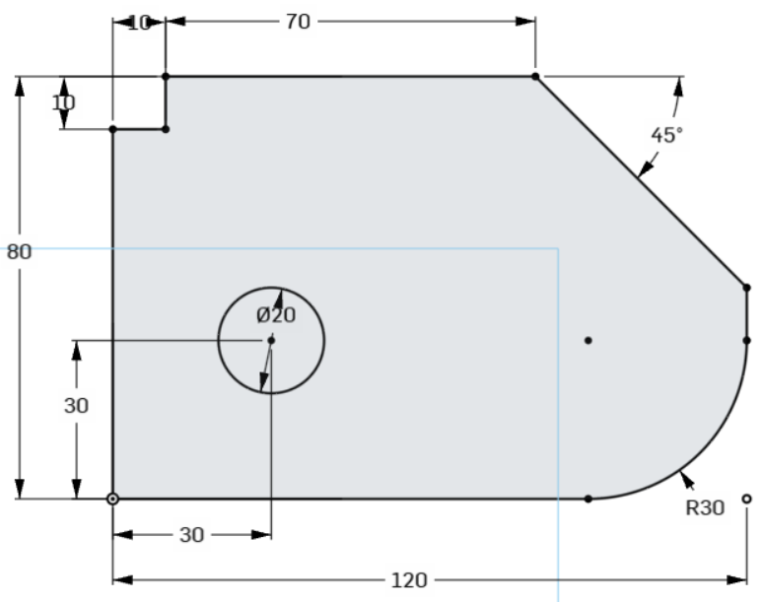

Select the Sketch command and set the drawing plane (Top). The drawing plane can be aligned with the screen in several ways:
- left-click on the Top surface of the cube, located in the upper right corner of the screen,
- right-click and select the last line in the menu,
- press the "n" key

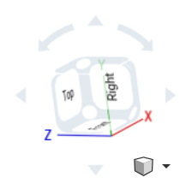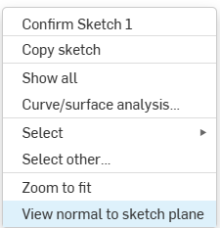

Using the sketching tools, we draw basic geometric entities (lines, circles, arcs, etc.). Using the "Line" command, we draw the outer contour of the sketch with straight lines. We will add the circular arc later.
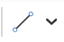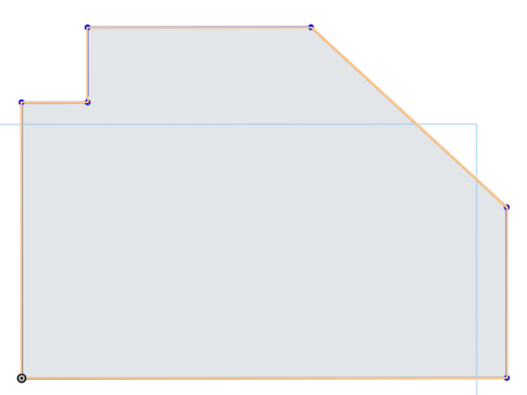
If necessary, add relations (e.g. parallelism, perpendicularity) to ensure correct geometric connections. Use the "Dimension" command to dimension the sketch so that it becomes fully defined (colored black).
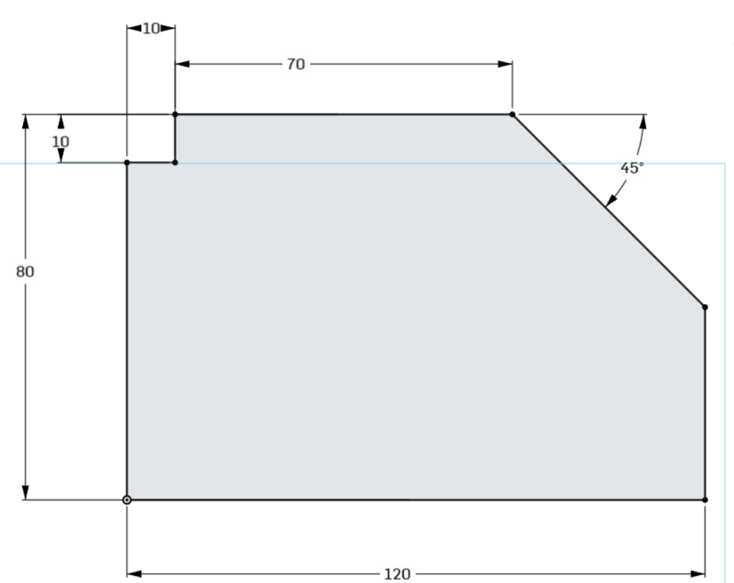
Using the "Sketch Fillet" command, we add a radius R of 30 mm to the contour.
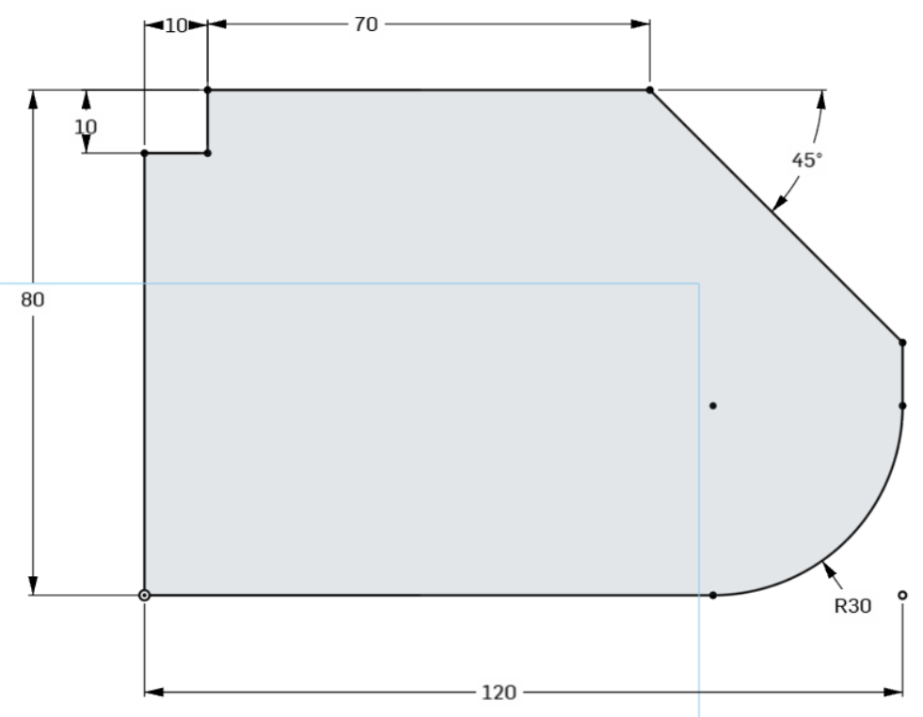
Using the "Center Point Circle" command, we add a circle to the sketch and specify its position and size.
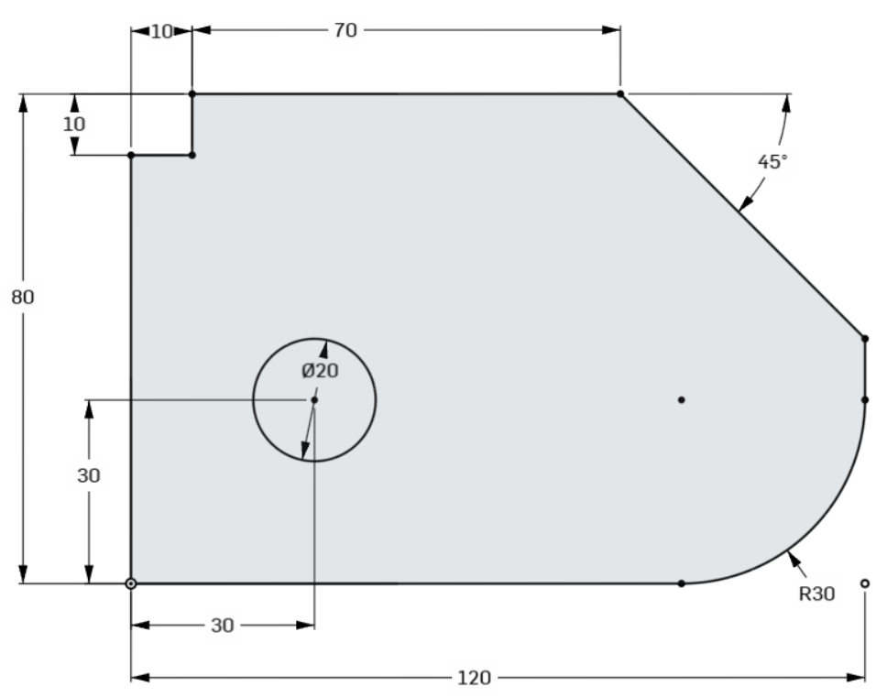

By clicking on the green check mark, we confirm the sketch so that it can be used for further modeling.
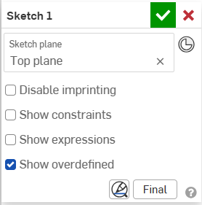

The sketch we created appears in the model tree. By right-clicking it, we can subsequently edit, rename, copy, export, etc.

Select the drawn sketch and use the "Extrude" command to extrude it into a space of 25 mm.
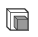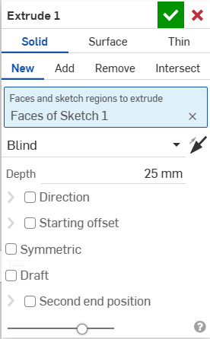

So we created our first 3D model with Onshape!

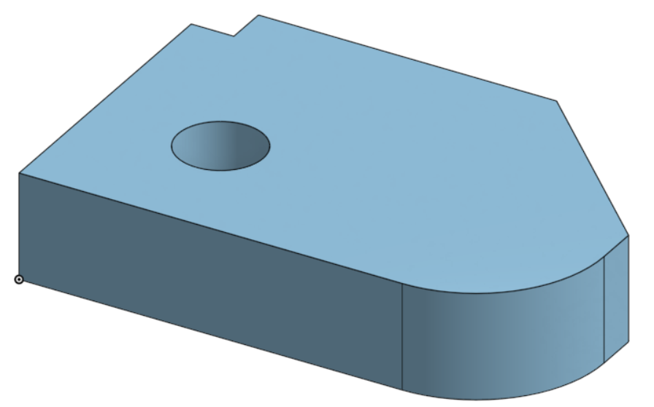

Task 2
In task 2, we will draw the sketch below.
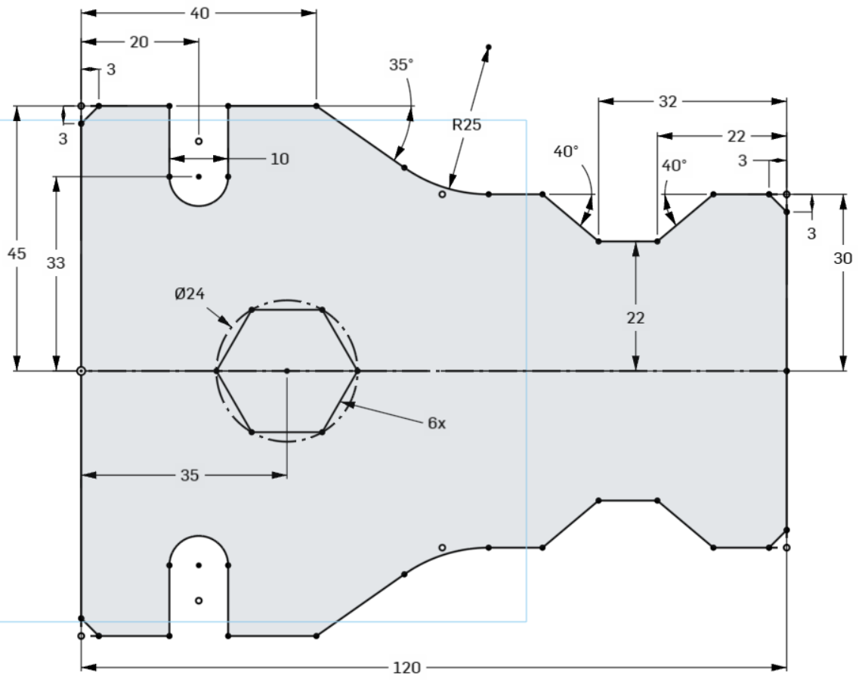
Within the same document, we will open a new Part Studio (click on the + icon in the bottom row).
Since the sketch is symmetrical, we will first draw only the top half on the Top plane and add dimensions to it. We will draw some details later.
We draw lines with the Line command, and add dimensions with the Dimension command.

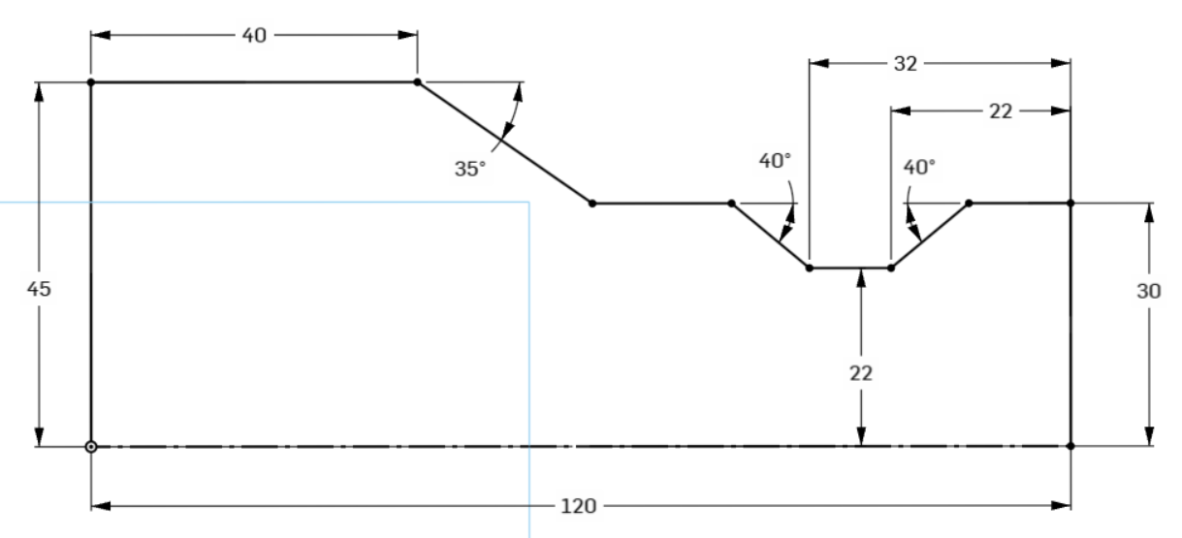.

Using the "Sketch Fillet" command, we add a radius R of 25 mm to the contour.
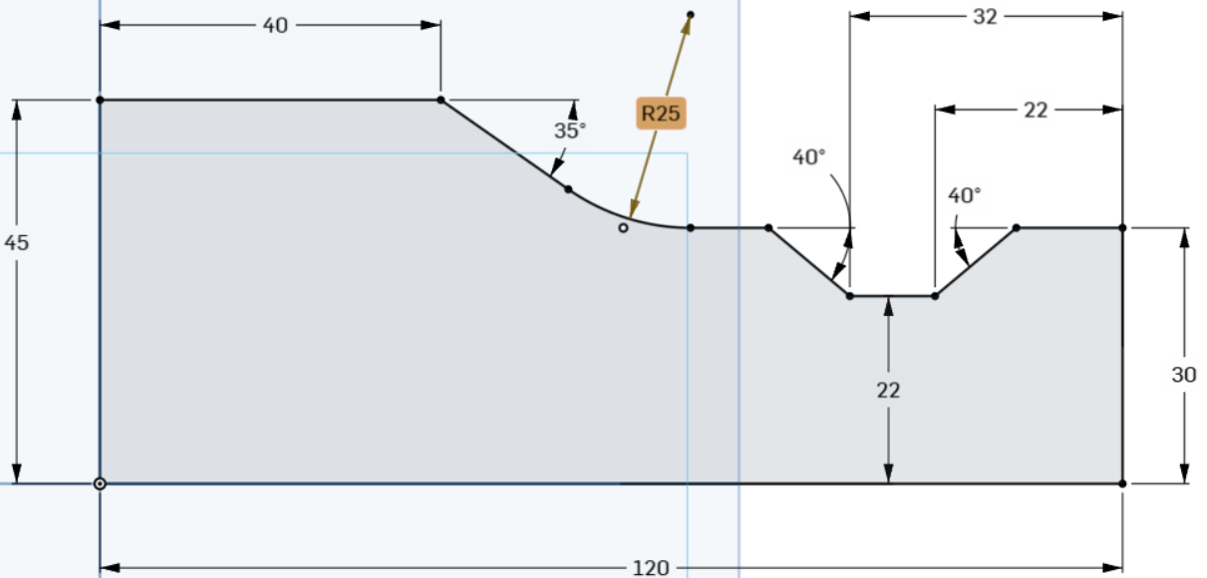
Using the Sketch Chamfer command, we cut the top 2 corners 3mm at a 45° angle. This command is hidden behind the Sketch Fillet command.
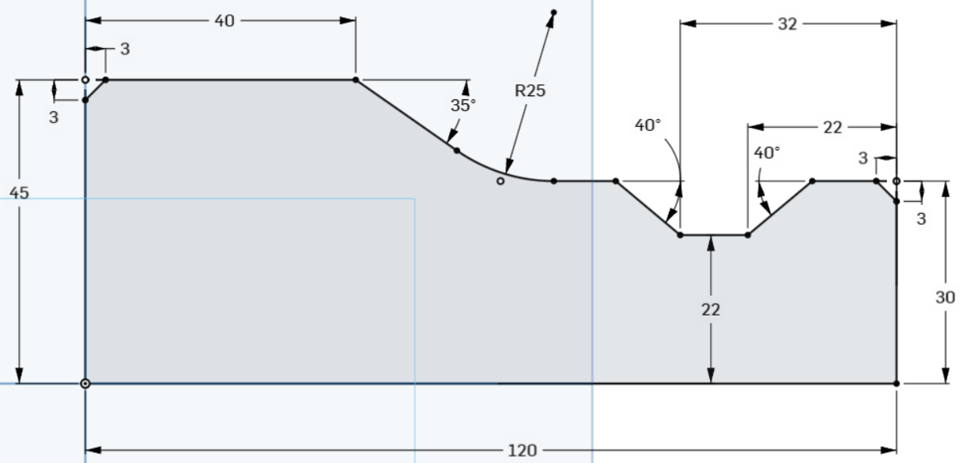
We also need to add an oval groove 10 mm wide. We draw this with the Line command. First, we draw a vertical line from top to bottom and confirm the point where the line transitions into a circular arc. From here on, it first offers us to draw a new line, but if we return to the same point and move away from it, we can continue drawing a tangent circular arc. We draw a circular arc and another line, which we connect to the existing contour. We also add the appropriate dimensions.
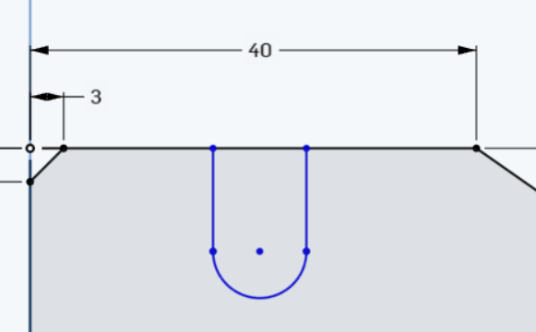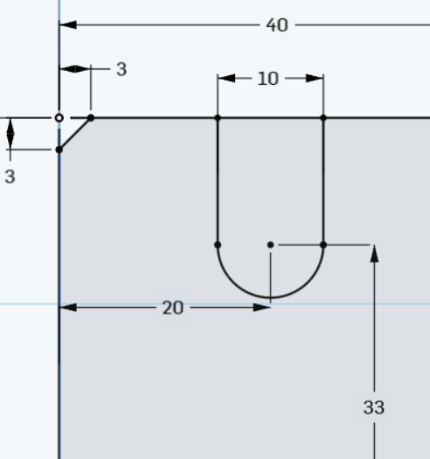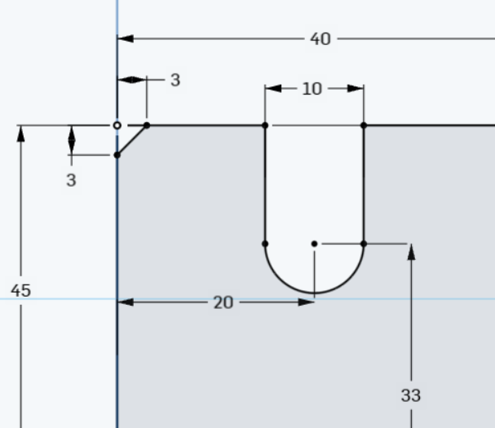

We need to break the top line at the groove location using the "Trim" command
Before mirroring the top half, we can change the bottom line into an auxiliary "Construction" line in two ways:
- select the line and use the “Construction” tool
- select the line with the right mouse button and select Construction

To mirror, we must first select all the elements we want to mirror. To select multiple elements, we can use the Shift key.
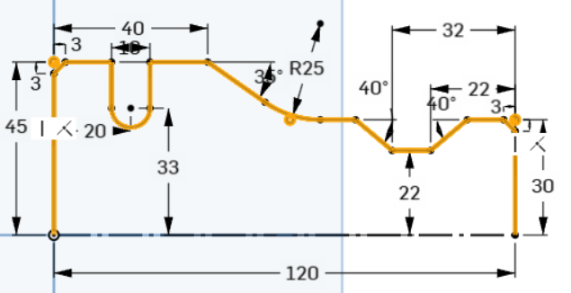
Once we have the elements selected, we use the "Mirror" tool and then select the line we want to mirror (the bottom line).
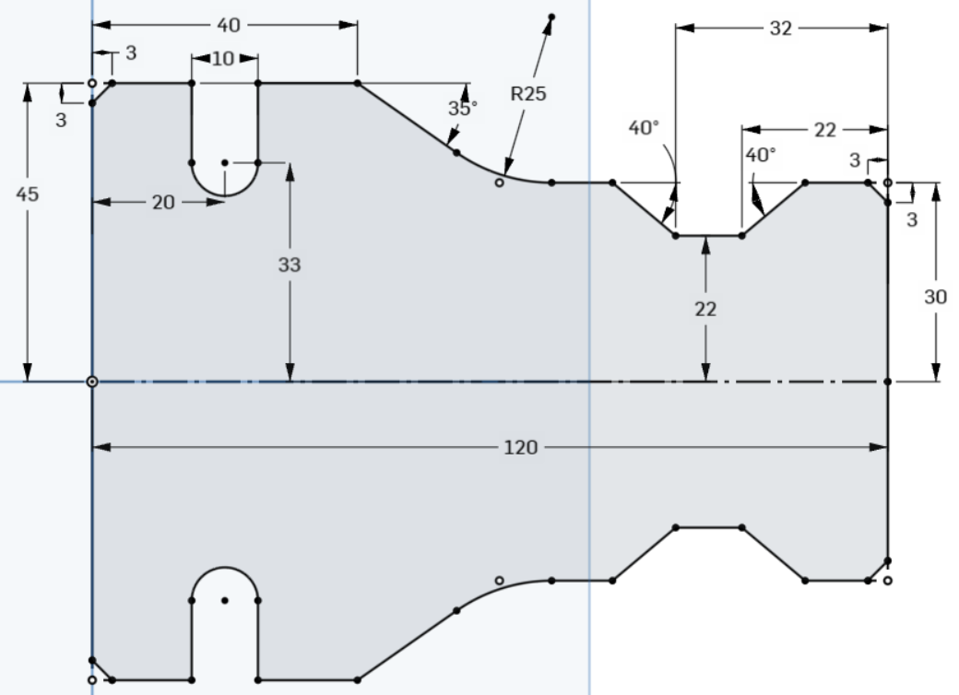
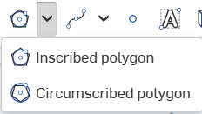
We will add a hexagon to the resulting shape and determine its size and position.
We add it with the "Circumscribed polygon" tool. We specify the center, one vertex, and the number of sides of the polygon (6x).
The size is determined by the diameter of the circle, and the distance from the left edge to the center is determined.

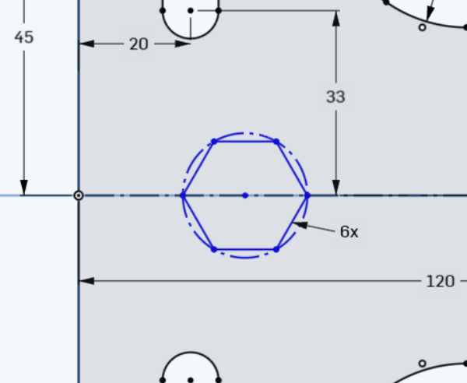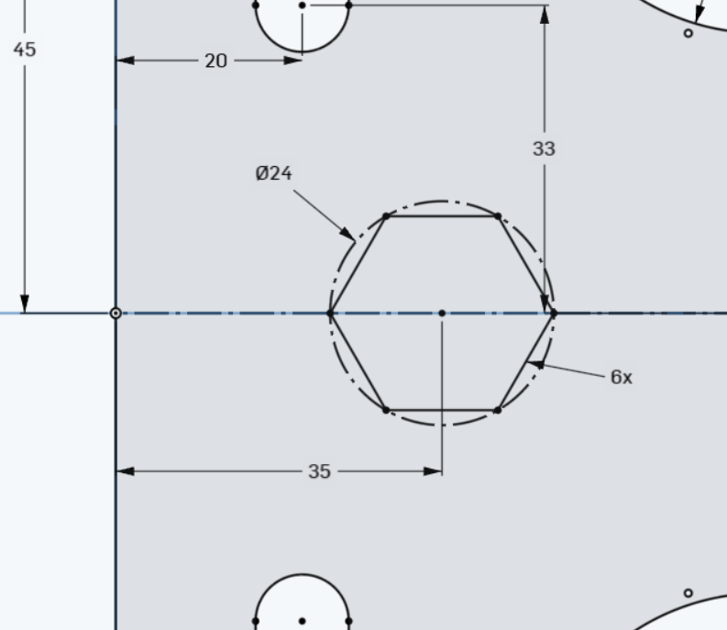
By clicking on the green check mark, we confirm the sketch so that it can be used for further modeling.
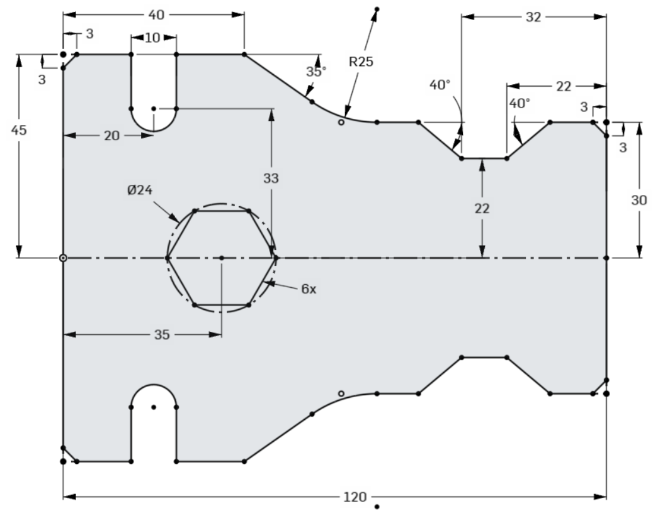
We select the drawn sketch and use the "Extrude" command to extract it into space by 25 mm.
Thus, we created another 3D model with the Onshape program!
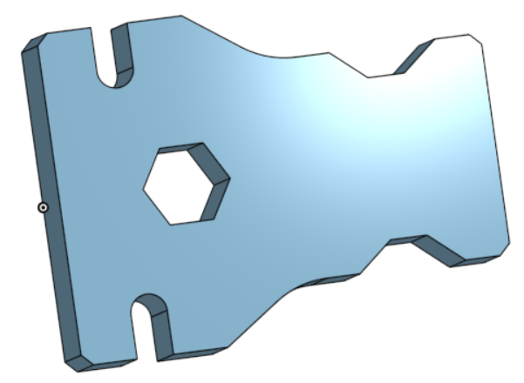

3D Model Building Blocks
When it comes to modeling, there are many different ways to achieve the same end result – a 3D model. Each technique has its advantages and disadvantages, so it is useful to know several approaches (operations) and adapt them to the type of object being modeled. Choosing the right method can save time and improve the accuracy of the model's details.

Sketches as a basis for 3D models
Sketches are the foundation upon which we build 3D solids. In Onshape, all solids are solid (as if made of material), allowing for realistic simulations and accurate technical designs.

Basic operations for making solid bodies:
- Extrude – creates a body by extruding a sketch into space.
- Revolve – shapes a body by rotating the sketch around a selected axis.
- Sweep – draws a sketch along a curve to form a body.
- Loft – connects two or more different sketches and creates a smooth transition between them.

Extrude
Extrude is an operation that extends a sketch into the third dimension and creates a 3D solid.
For example, a rectangle can be converted into a cuboid, or a circle into a cylinder.
When extracting, we determine the depth, which can be defined in several ways:
- Blind – by entering a numerical value (fixed depth).
- Up to – to the selected entity (surface or solid) in the model.
- Through all – the extract runs through the entire geometry in the selected direction.

The extraction can take place in one or both directions, which can be adjusted as desired.
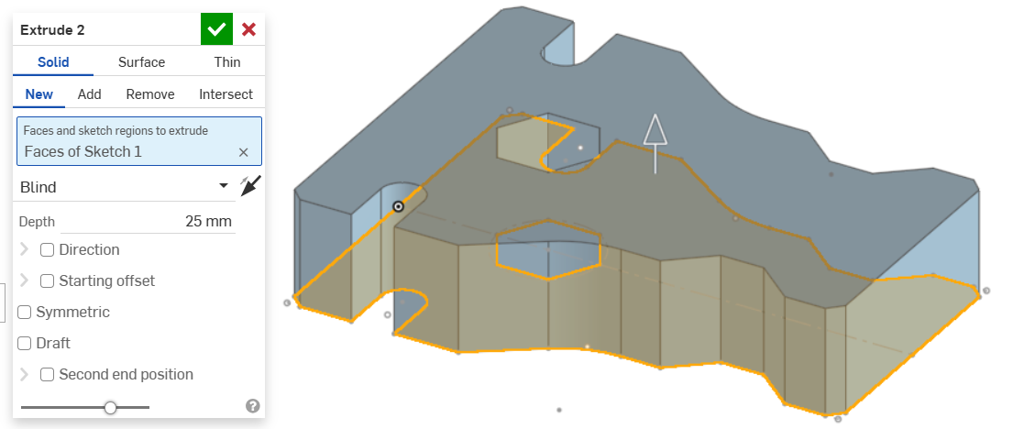

Revolve
Revolve is an operation that rotates a 2D sketch around a selected axis to create a 3D solid. In addition to the sketch, it is also necessary to specify the axis of rotation when rotating.
The range of rotation is determined by the angle of rotation, which can be:
- Partial rotation – any value up to 360° (or 2π rad).
- Full rotation – 360° rotation, which is the most common choice.

Rotation is especially useful for modeling rotationally symmetrical objects such as axes, shafts, bolts, and similar parts.
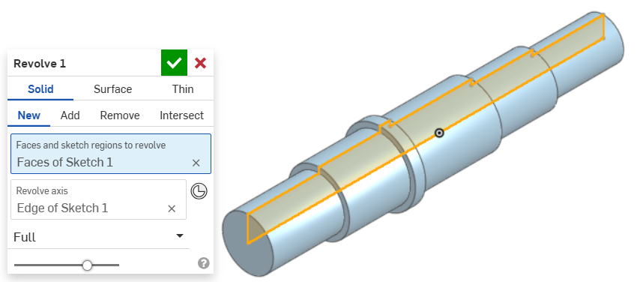

Sweep
Sweep is an operation that creates a 3D body by dragging a sketch (profile) along a selected path. The path can be a straight line, a curve, or any closed path
This technique is particularly useful in the design of profile structures such as pipes, standard profiles and other elongated elements with a constant cross-section.

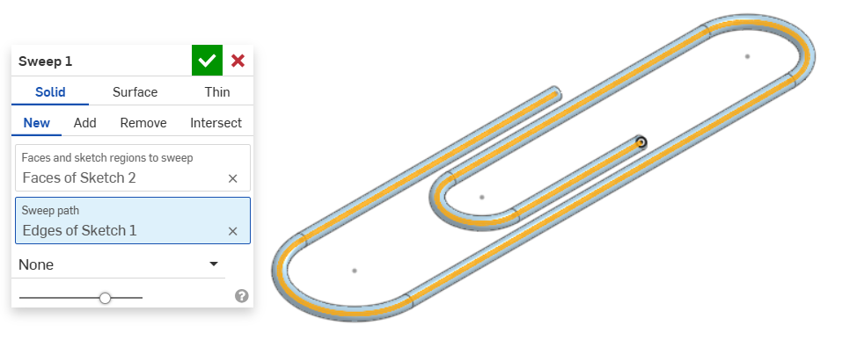

Loft
Loft used when we want to create a surface or solid by smoothing the transition between two or more different profiles. To create a solid, the sketches must be closed. When tensioning, we can adjust the way the profiles connect and, if necessary, add guide paths for a more controlled transition.
It is an operation that connects two or more sketches (profiles) to create a three-dimensional body or surface.

Key elements of tensioning:
- Profiles – two or more sketches that are connected (they can have different shapes).
- Guide curves – additional curves that help control the transition between profiles.
- End conditions – control how profiles connect (e.g. smooth or sharp transitions).

It is used when extrusion or rotation are not flexible enough to design complex transitions, because it allows you to create gradual transitions between different shapes.
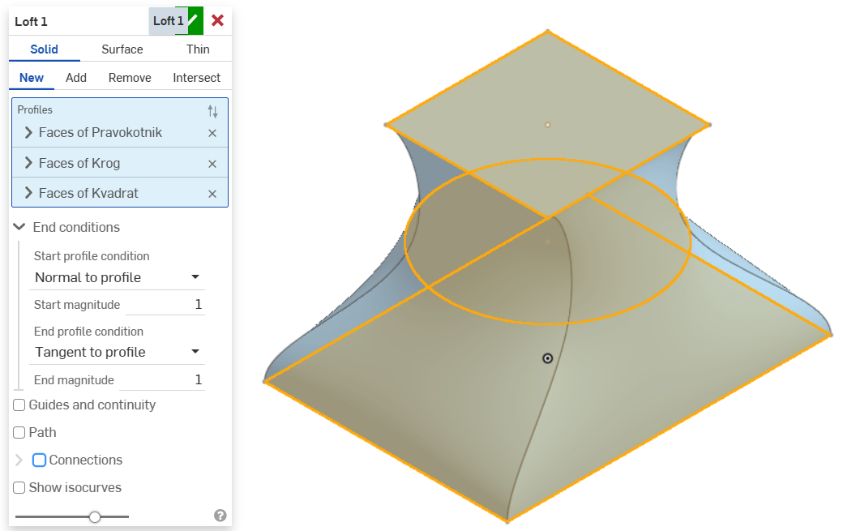
All of the above-mentioned widgets support Boolean operations, which allow for different ways of combining bodies. In addition to Add, we can use Remove or Intersect, depending on the desired result. When creating a new widget, we can decide whether it will be part of an existing body or whether it will represent a new, separate body in the model (New).
This means that we can create multiple separate bodies in one Part Studio, which allows for multi-body modeling. We can perform Boolean operations between individual bodies, connect them associatively, and later transfer them to an Assembly. If we want models that must fit perfectly in an assembly, we can adjust their shape within the same Part Studio.
If we want to model surfaces instead of solid bodies, we select the "Surface" option. To model hollow bodies, we can use the "Thin" option, in which case we must also define the wall thickness of the body.

In addition to the four main building blocks mentioned above, there are a number of additional tools for finishing 3D models.
Chamfer – produces picked edges
Fillet – round selected sharp edges of an element
Draft – tilt the body surfaces at an angle
Rib – we make a reinforcing rib
Shell – we hollow out any three-dimensional body
Hole – we produce standard/non-standard bores
Thicken – we add thickness to the selected surface

If the model contains a large number of identical components (e.g. holes, shapes or ribs), their individual production would be time-consuming. In such cases, we use sampling, which multiplies the component multiple times according to the selected pattern.
Sampling can be carried out in three ways:
- Linear – arrangement in a straight line, in two directions (Linear Pattern),
- Circular – arrangement around the axis of rotation (Circular Pattern),
- Curve – arrangement along a selected curve (Curve Pattern).

Copies remain linked to the original component - a change to the base component is automatically reflected in all sampled copies. We can sample models, model components, and surfaces.
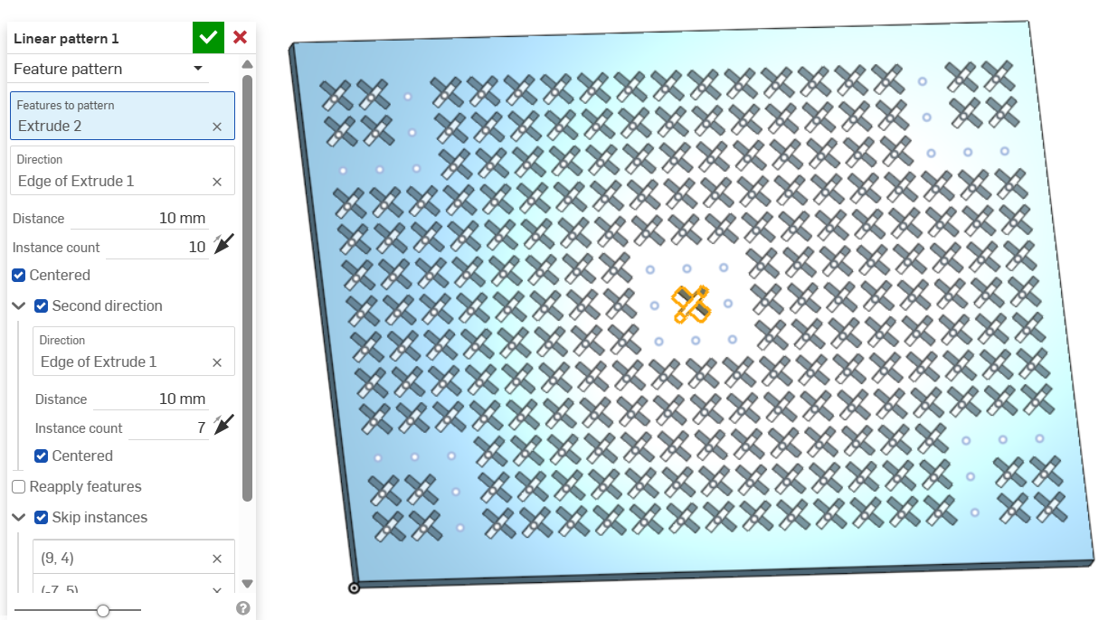
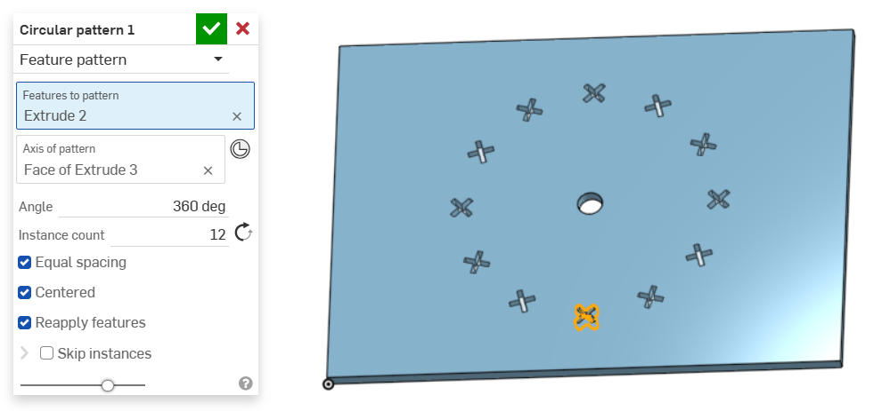
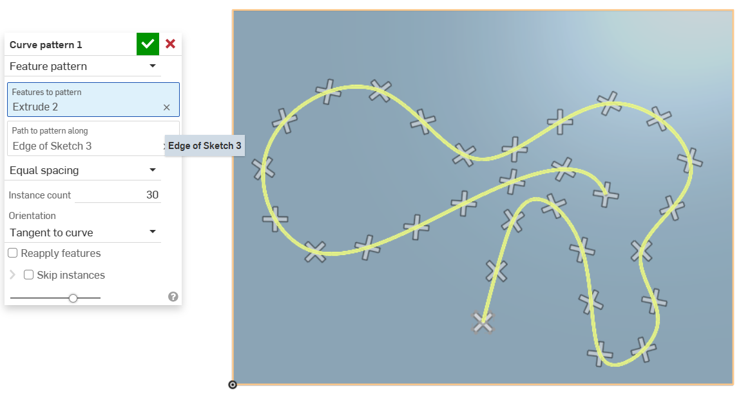
The Mirror tool makes it easier to create mirrored parts. It allows you to mirror entire models, individual components, or individual surfaces relative to a selected mirror plane of the model.
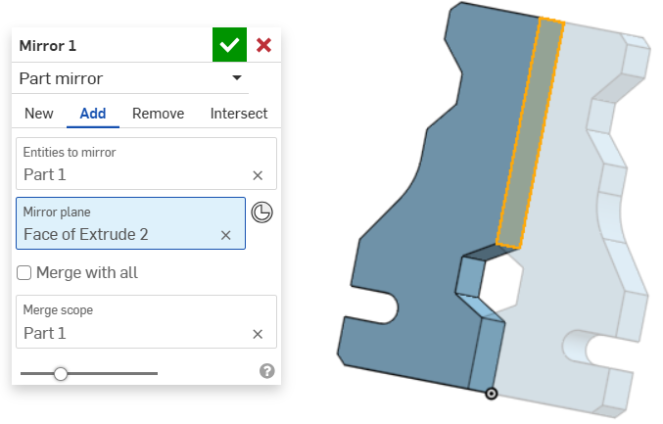
When creating more complex models, we often need sketches that do not lie on the basic reference planes. Therefore, we can create auxiliary planes that are defined based on the existing geometry of the model or the basic planes and have certain relations with them.

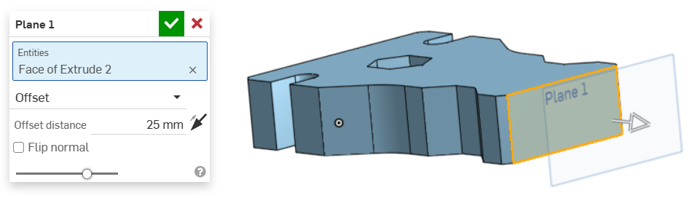

Task 3

In the next task, we will repeat the process of creating sketches and using the extrude tool.
Draw the first sketch on the Right plane and dimension it.
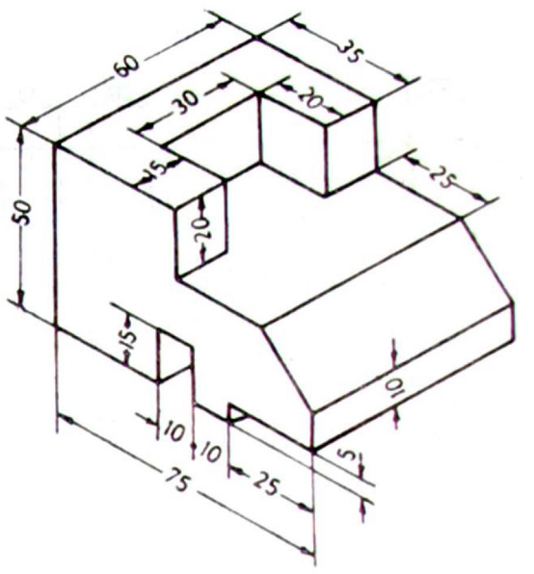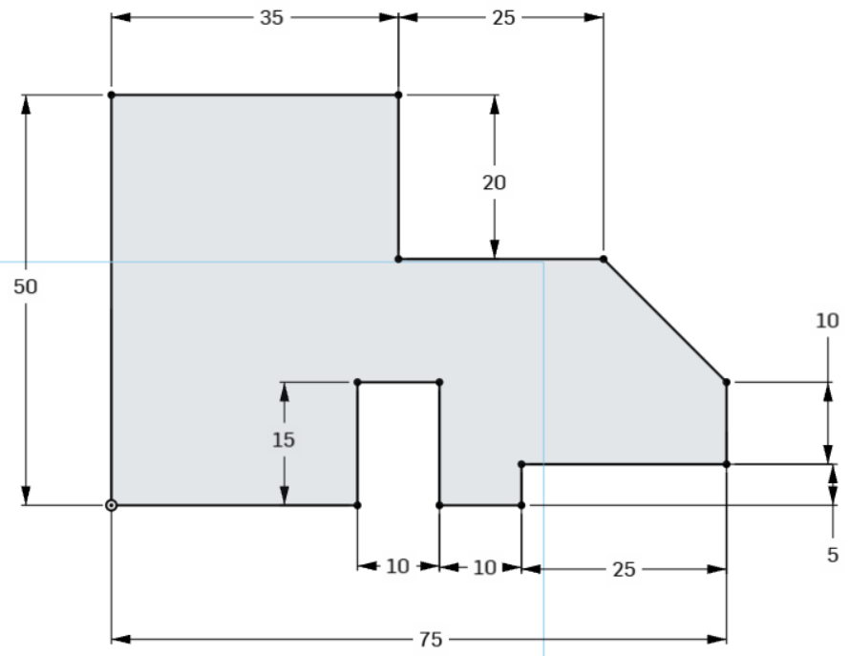

In the next step, we stretch the first sketch into space by 60mm. Given that the object is symmetrical, it makes sense to extract it to both sides of the plane (Symetric).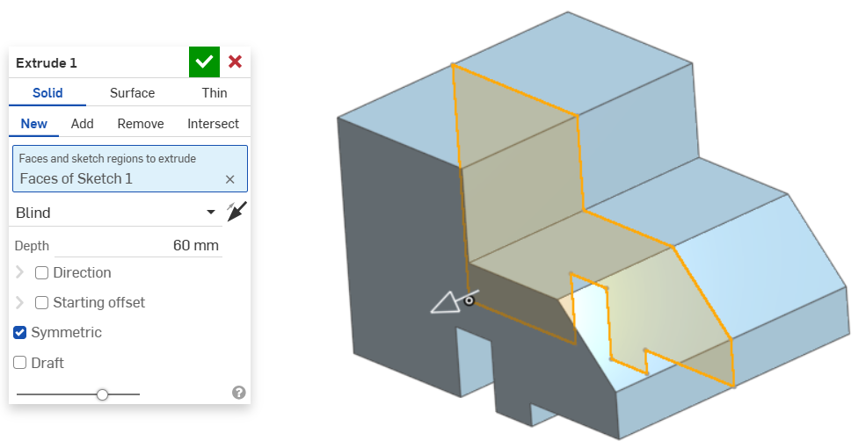

On the top surface of the model, draw another sketch containing a rectangle with dimensions of 20x30 mm and remove the volume up to the midface.

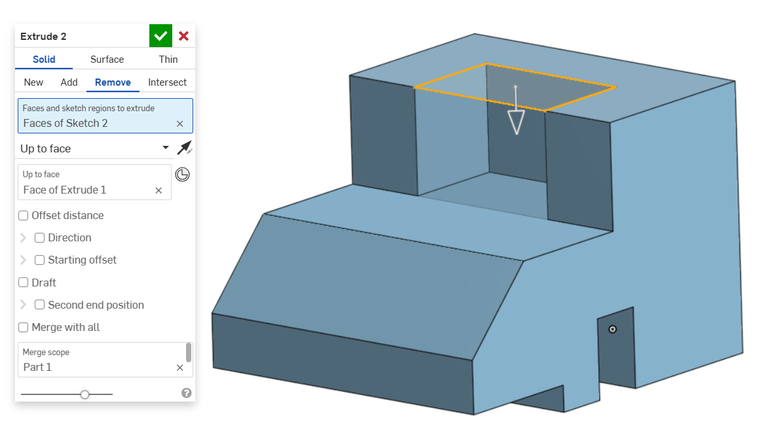

Task 4
In task 4, we will learn about the Revolve building block, creating additional parallel planes, and repeating the volume subtraction with the Remove tool.
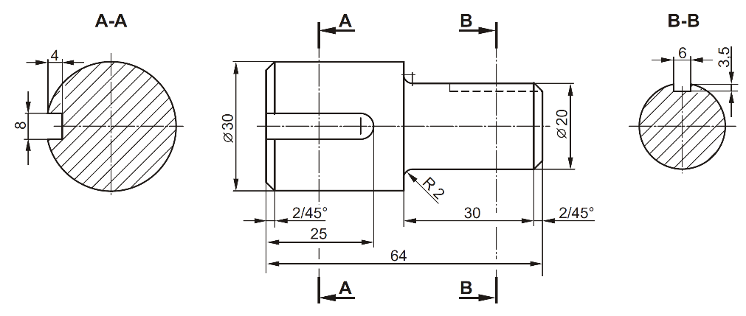On the plane (Front) we draw a sketch containing the upper half of the spindle cross-section.
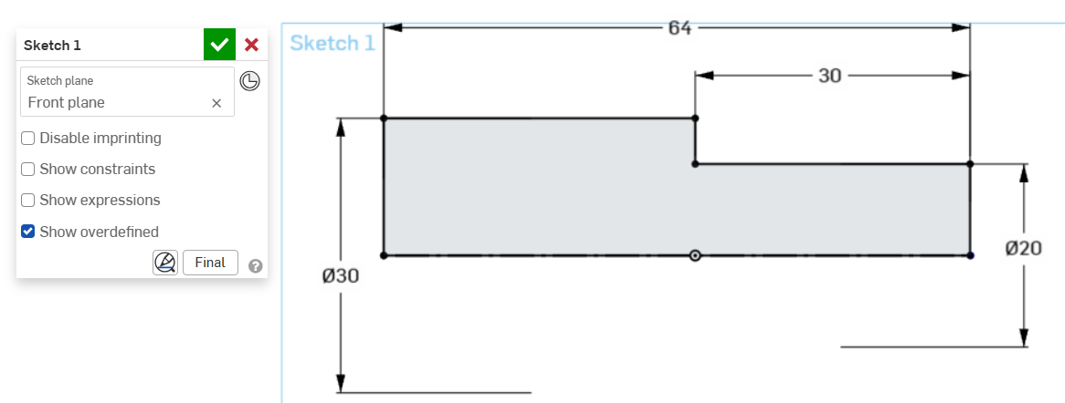
Using the Revolve tool, we rotate the sketch around an axis, creating a spindle volume.
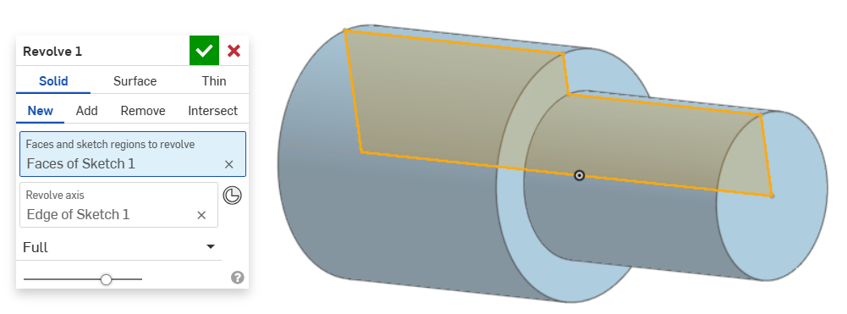

Add a 2 mm bevel to both sides of the shaft, at a 45° angle.
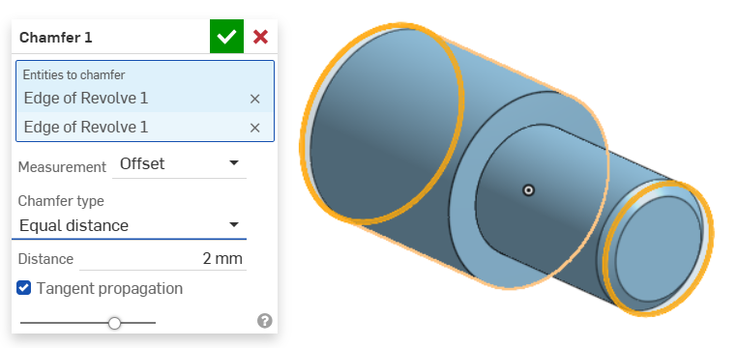
In the middle of the shaft, round off an edge with a radius of 2 mm.
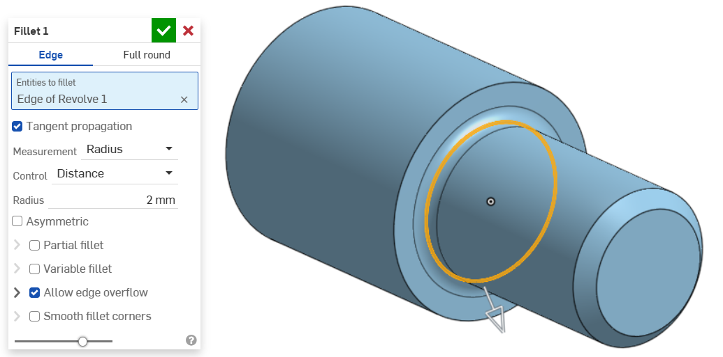
We create a parallel plane (Offset) 10 mm from the Top plane so that it is tangent to the smaller diameter on the shaft.
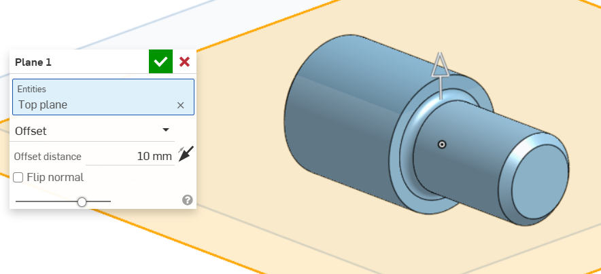
On the new plane, we draw a sketch of the groove and create it.
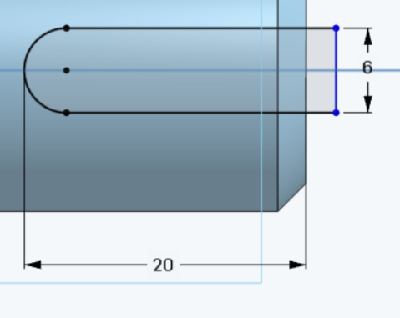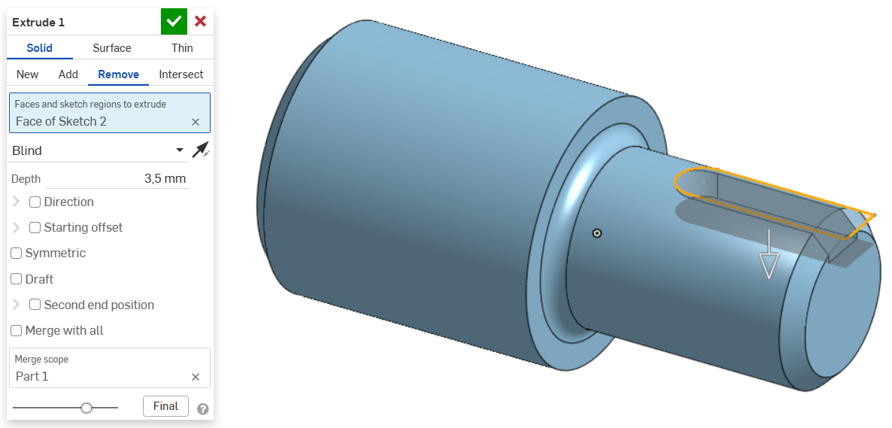
This time we create another parallel plane from the Front plane at a distance of 15 mm.
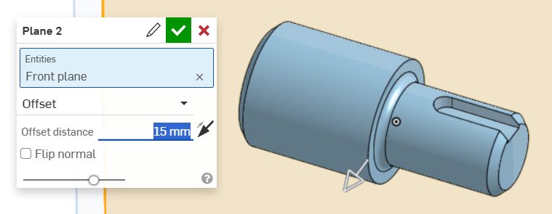

We also draw a sketch of the groove on this plane and make it too.
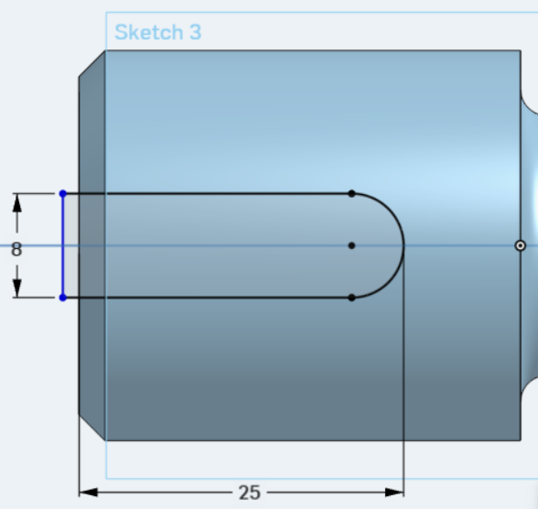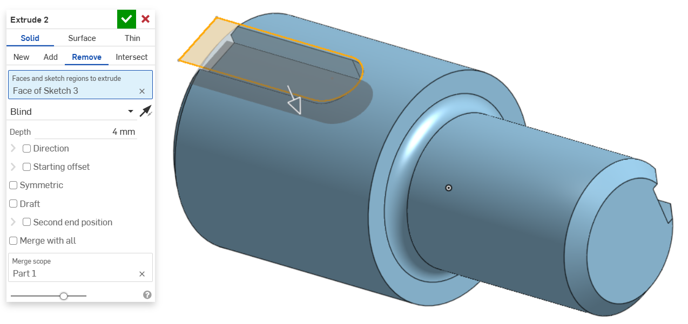

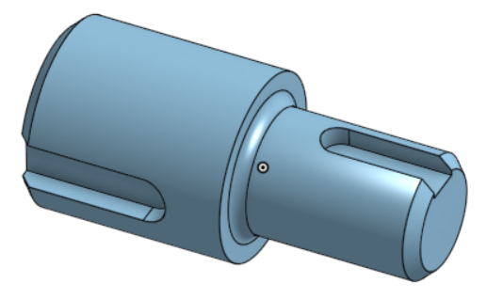

Task 5
In task 5, we will learn how to create a model by dragging a circular cross-section along the median.
Draw a sketch of the centerline of the clip on the TOP plane. Make sure that the coordinate origin is at the inner end of the centerline of the clip (the circle with a dot). On the Front plane, draw a circle with a diameter of 1 mm, which represents the cross-section of the clip.
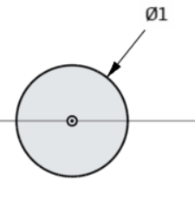
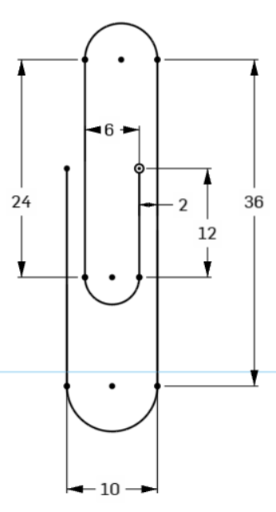
Using the Sweep tool, draw the circle of the second sketch along the curve (centerline) of the first sketch.
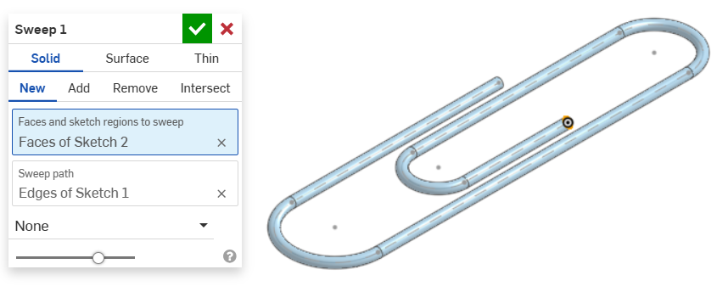

Task 6
In this task, we will repeat the use of the Extrude tool, and we will also learn about the tools for creating round holes (Hole) and the Loft tool, which is intended for creating models with different cross-sections.
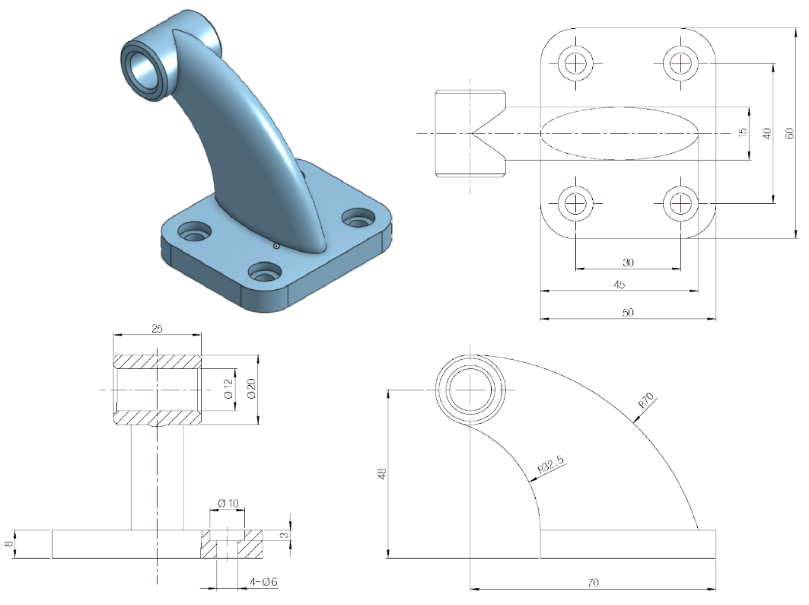
On the Top plane, draw a 40x60 mm rectangle from the center point. Extrude the sketch into the space by 8 mm.
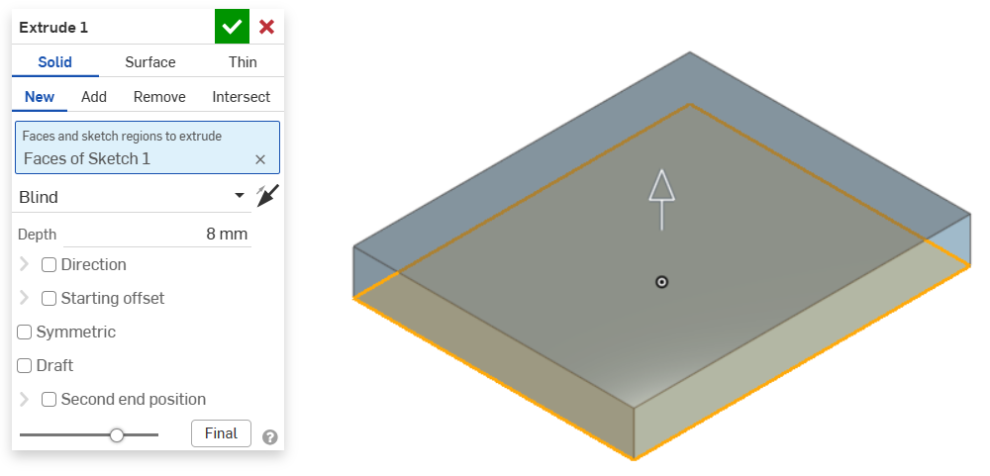
Use the Fillet tool to round the corners with a radius of 10 mm.
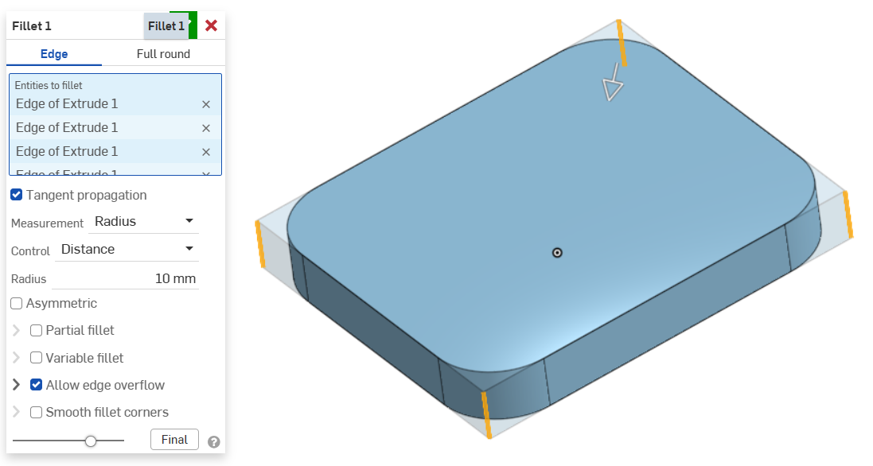
On the top surface of the model, draw a sketch with 4 points (Point) in the centers of the radii, which represent the centers of the screw holes.
Using the Hole tool, select all 4 points and create through (Up to next) holes for Counterbore screws, 6 mm in diameter, which are enlarged to a diameter of 10 mm at the top and deepened by 3 mm.
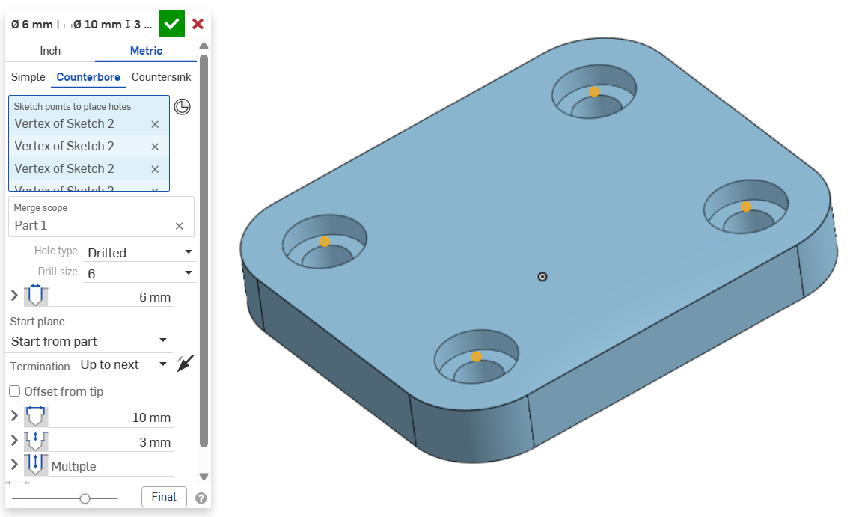

On the Front plane, draw a circle with a diameter of 20 mm, which we will later use to build the model.
On the top surface of the tile, draw an ellipse with dimensions of 15x45 mm, whose center lies on the Front plane and is tangent to the front edge of the tile.

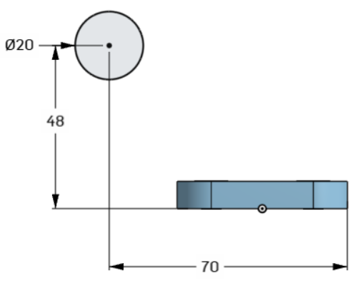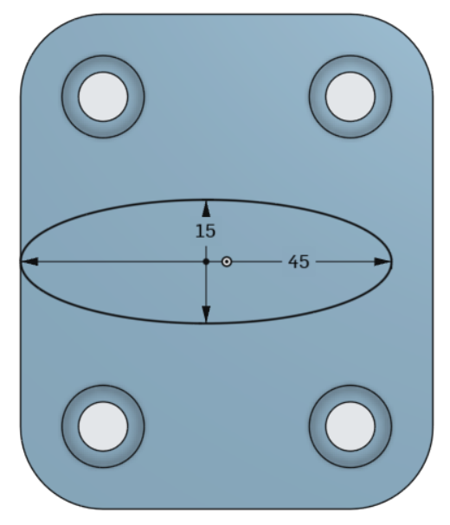

We create a parallel plane that is 45 mm in front of the Right plane and passes through
the center of the circle.

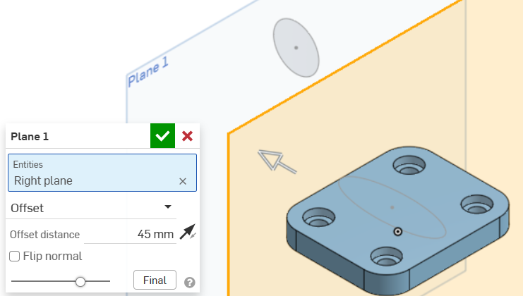

On the new plane, draw an ellipse with dimensions 15x20 mm. The center of the ellipse is aligned with the Front plane and is 48 mm away from the bottom edge.

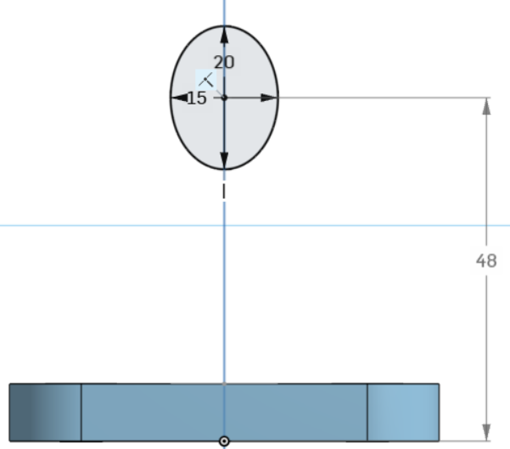

On the Front plane, we draw two circular arcs (Arc) connecting the extreme points of ellipses that lie on different planes.

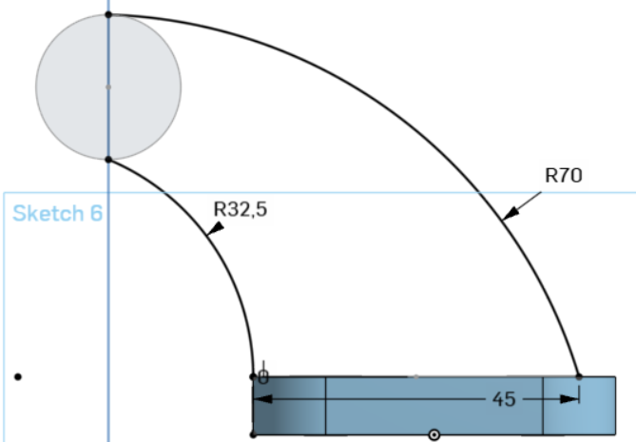
Using the Loft tool in the Profiles window, select both ellipses, and in the Guides window, select both circular arcs connecting the ellipses.
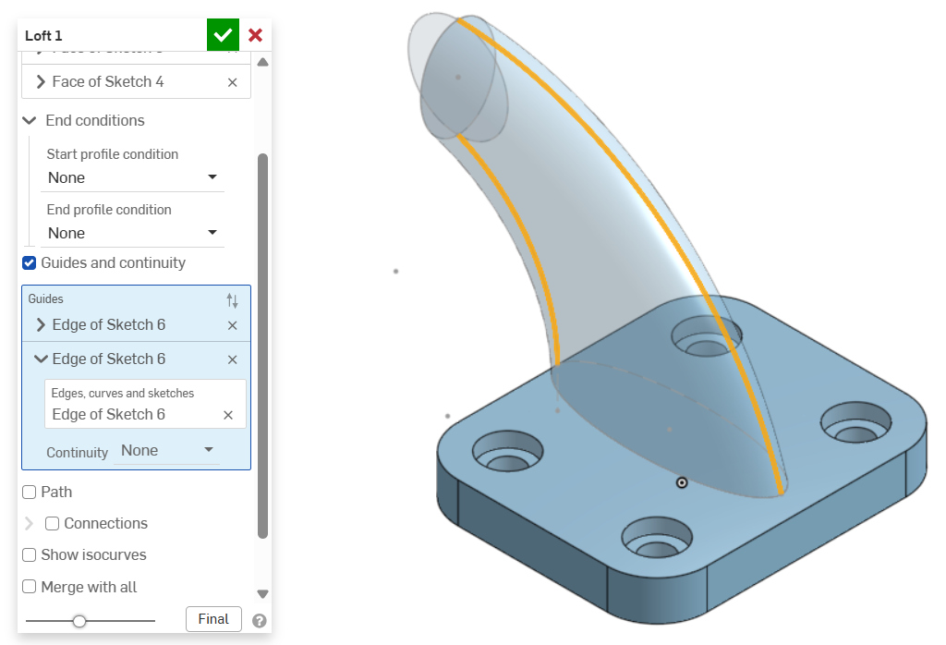
Use the previously drawn circle with a diameter of 20 mm and use the Extrude tool to create a cylinder with a length of 25 mm. Since the cylinder is extruded equally on both sides, check the Symmetric box.
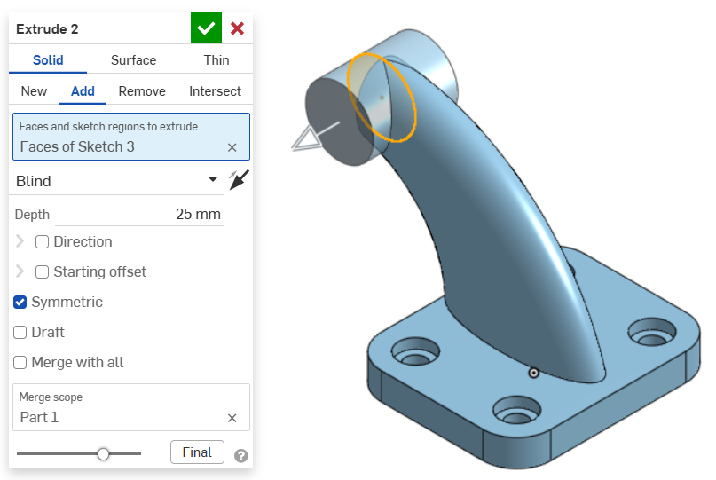
On the side of the cylinder, draw a sketch, and in it a point that represents the center of the hole.
At this point, make a through hole (Hole) with a diameter of 12mm.
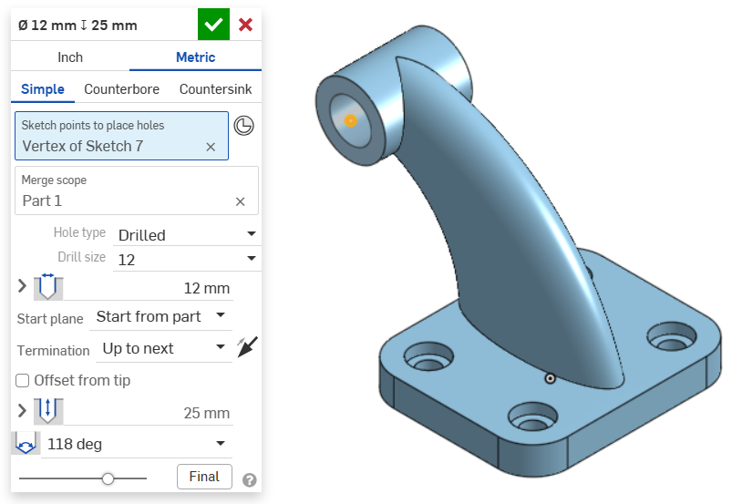
On both sides of the cylinder, add a 1 mm bevel, at an angle of 45°.
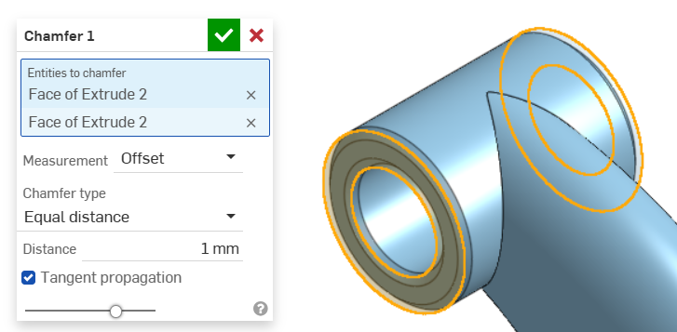

Exporting 3D models
As I mentioned in the introduction, it is possible to export 3D models to various formats. The most common ones are:
- STEP and IGES, which are used to exchange models with other modeling programs,
- STL, used for 3D printing needs.
Export process
Individual 3D models can be exported by right-clicking in the bottom navigation bar and selecting export.
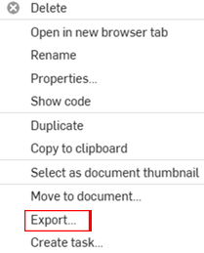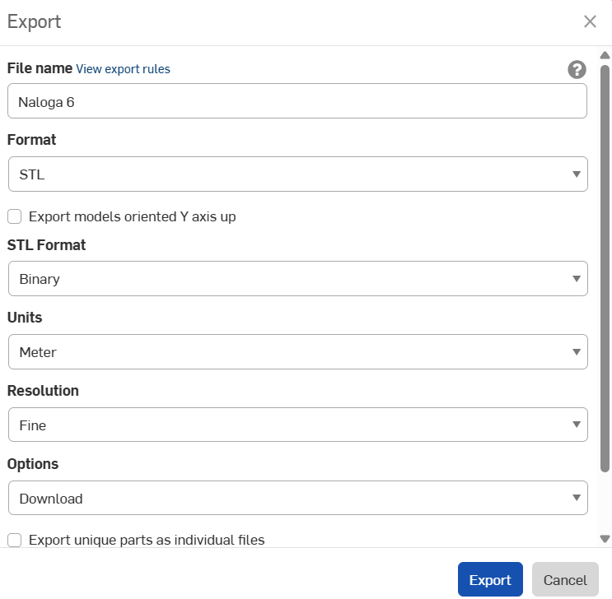

A larger window will open, in which we can select the name of the exported file, the format, the units of measurement and the accuracy of the record. I suggest you select the Download option, which will transfer the file to your computer and make it easier to use it further.

Conclusion
In this guide, we learned the basic principles of 3D modeling with Onshape. It should be noted that Onshape offers much more than assembly, drawing, and cloud services that, in addition to modeling, enable real-time collaboration between multiple users and efficient data management.

Bibliography
The 3D Printing Journal, (2022). Hideo Kodama. Obtained 8.3.2025, 4. 12. 1980: Hideo Kodama je vložil patentno prijavo za prvo tehnologijo AM v zgodovini, zdaj znano kot stereolitografija (SLA).
3D Printing Industry, (2022). Charles (Chuck) Hull. Obtained 8.3.2025, https://3dprintingindustry.com/news/father-of-3d-printing-sells-significant-share-holding-in-3ds-7579/
Introduction to Fused Deposition Modeling (FDM), 2024. Fused Deposition Modeling (FDM). Obtained 8.3.2025, https://dozuki.umd.edu/Wiki/Introduction_to_Fused_Deposition_Modeling_%28FDM%29
3D Printing: The Next Industrial Revolution, 2020. Selective Laser Sintering (SLS). Obtained 9.3.2025, https://3dprintingfuture.weebly.com/the-technology.html
Wikipedia 1:, 2009.: Project RepRap. Obtained 9.3.2025, https://el.wikipedia.org/wiki/%CE%A4%CE%BF_project_RepRap
Računalniške novice:, (2019). Obtained 10.3.2025 https://racunalniske-novice.com/natisnili-prvo-srce-s-cloveskim-tkivom-in-zilami/
3Dnatives Europe:, (2020).. Obtained 10.3.2025 https://www.3dnatives.com/en/3d-printed-house-in-belgium-230720204 /
Amazon:, (2025). Obtained 10.3.2025, s https://www.amazon.de/
The University of Texas at Arlington:, (2024). Obtained 10.3.2025, https://cseseniordesignkb.uta.edu/introduction-and-synopsis-for-3-d-printing/
Prusa Research:, (2024). Obtained o 10.3.2025, https://help.prusa3d.com/article/extrusion-multiplier-calibration_2257
Innovative Drive Systems:, (2024). Obtained 10.3.2025, https://www.innodrivesys.eu/nr-1-filament-aus-der-liste-pla-plus-pla/
Onshape application:, (2025) Obtained 10.3.2025, www.onshape.com .

